Cuboctahedron
The cuboctahedron is a 3-dimensional shape known as an Archimedean solid. An Archimedean solid is a semi-regular 3-dimensional shape, unlike a Platonic solid, which is a regular 3-dimensional shape. An Archimedean solid is made up with regular shapes for faces, but not each shape is similar. In this case, the cuboctahedron is made up of eight equilateral triangles and six square faces, all regular shapes, but not all similar. This gives the cuboctahedron a total of 14 faces. There are twelve vertices; at each vertex, the vertices of two squares meet up with the vertices of two triangles, making for a total of four faces meeting at each vertex. Although it is not a Platonic solid, the cuboctahedron has plenty of interesting properties of its own. Keep reading, as various methods for building the cuboctahedron, finding its volume and its surface area will be discussed.
There are plenty of methods that can be used to find the measurements for side lengths, surface area or volume for the cuboctahedron. Keep in mind that surface area is the total sum of the area of all of the faces of a 3-dimensional figure and volume is the amount of space a 3-dimensional figure takes up. The best method to use for finding the side lengths of the cuboctahedron is using the base of the cube and marking the midpoints. Then, when a line is drawn from one midpoint to the midpoint of an adjacent edge (a side connected to the original side by a vertex), the measurement of the line that connects them is the side length of the cuboctahedron. In this case, the cube will have a side length of 19.8 units.
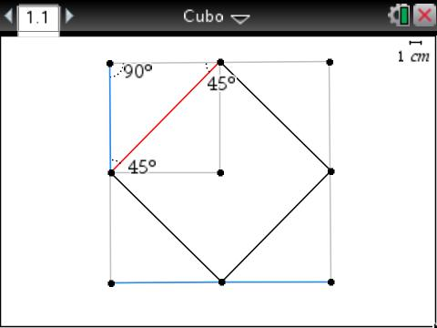
x
x√2
x
Figure 1. Finding the Side Length of a Cuboctahedron
Figure 1 shows one method for finding the measurement of the side length of a cuboctahedron. As shown as the blue line on the bottom of the square, a single side length is equal to the measurement of the variable x which, in this case, is 19.8 units. The blue line on the left side of the square is the segment that connects the midpoint of the side to the vertex. This makes the measurement of that side x, or in this case half of 19.8, which is 9.9 units. A basic understanding of special right triangles – also known as 45-45-90 triangles – is required to find the final side length of the cuboctahedron. In a 45-45-90 triangle, the two legs are always congruent, and the hypotenuse (the line directly across from the 90 degree angle) is always equal to the measurement of one of the legs multiplied by √2. In this case, that makes the final measurement 9.9√2 units.
This number is the same measurement for every side of the cuboctahedron, including the side lengths of the triangle faces.
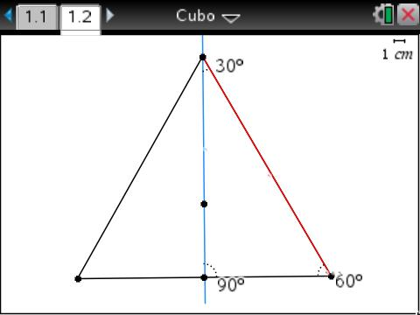
x√2
x√2(√3)
or
x√6
x√2
Figure 2. Finding the Area of a Triangular Face of the Cuboctahedron
Figure 2 shows the side lengths necessary for finding the area of one of the triangular faces of the cuboctahedron. The red length highlighted shows the measurement that was found to be the side length of the cuboctahedron, which was x√2, or in this case, where x = 19.8, 9.9√2 units. From here on out, a basic knowledge of 30-60-90 triangles is necessary to solve for the measurement of the altitude, which is needed to find the overall area of the triangle. In a 30-60-90 triangle, the hypotenuse is always twice the size of the side opposite the 30 degree angle. This makes the side that connects the 90 degree and 60 degree angles x√2. In this case, where x is the side length of the cube, which is 19.8 units, of x is 4.95, which makes the overall measurement of the side length between the 90 degree and 60 degree angles equal to 4.95√2 units. In a 30-60-90 triangle, the side opposite the 60 degree angle is always the measurement of the side opposite the 30 degree angle multiplied by √3. That makes the measurement of the blue line highlighted in Figure 2 equal to x√2(√3), which simplifies to x√6. When the value for x is substituted into the expression, the altitude of the triangle face of the cuboctahedron is found to be 4.95√6.
Now that the side lengths and altitudes for the two types of faces for the cuboctahedron are known, the areas of the faces can be found using the formulas shown in Figure 3 below.
x = side length of cube
x = 19.8

A_{sq} = (x√2)²
A_{sq} = (9.9√2)²
A_{sq} = (9.9√2)(9.9√2)
A_{sq} = 98.01(√2)(√2)
A_{sq} = 98.01√4
A_{sq} = 98.01(2)
A_{sq} = 196.02 units²

A_{tri} = (½x√2)(¼x√6)
A_{tri} = (9.9√2)(4.95√6)
A_{tri} = (4.95√2)(4.95√6)
A_{tri} = 24.5025(√2)(√6)
A_{tri} = 24.5025(√12)
A_{tri} = 24.5025(2√3)
A_{tri} = 49.005√3 units²

A_{sq} = area of square face of cuboctahedron
A_{tri} = area of triangular face of cuboctahedron

Figure 3. Finding the Areas of the Cuboctahedron’s Faces
Once the areas of the two types of faces are found, finding the surface area of the cuboctahedron becomes a simple process. The areas just have to be added

