Essay 2

You wrote an essay on the relationships between the derivative and the integral…..

1. In your paper, you discussed the Intermediate Value Theorem. Tell us about it. How does it apply to the example below on the interval from x = 2 to x = 6?

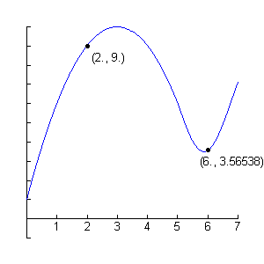

2. In your paper you discussed BOTH forms of the Fundamental Theorem of Calculus. Use this knowledge to answer the following questions:

a)  where a, b, c, and d are constants

b) If h(x) = ( where a, b, c and d are constants, find h’(x)

3. Referring to the graph of g’ below…..describe how you can determine

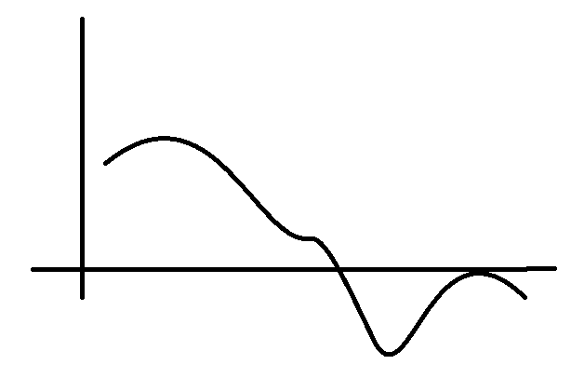

a) the maximums and minimums

b) the points of inflection and concavity