Essay 3

You wrote a paper on Riemann sums, the trap rule, Simpsons’ rule, etc.

1. In the interval from 1 to 7, sketch and discuss the appropriate approximation and sum (use 3 sub-intervals in each).

Upper Riemann Lower Riemann Midpoint
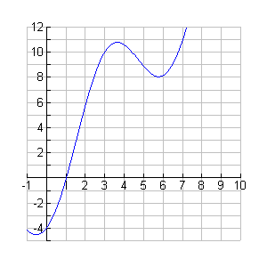

2. Compare and contrast the Midpoint approximation above with a Trapezoidal Rule with 3 sub intervals
3. Set up the integral to find the exact value for the area under the curve if the function above is
y = -4cos(x)+2x

4. If the above integral is for the velocity of a particle, how would you find the average velocity in the interval from 1 to 7?

