GAT FINAL EXAM REVIEW 2014  
Here are some problems to help direct your studying! Remember that around 80% of the exam will come from this packet and the remaining 20% will come from your old quizzes and tests.

For 1& 2, Given ABC A(9,2) B(-8,-1) C(1,-6)

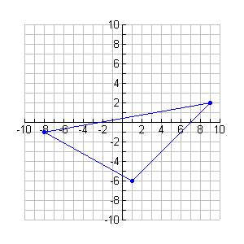

1. Write the equation of the median from A to 

2. Write the equation of the altitude from A to 

3. Given: (x + 3)2 + (y – 4)2 = 25 Graph and find the x and y intercepts algebraically.

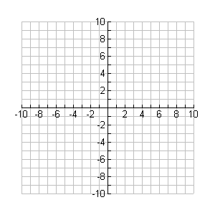

4. How many real roots does this curve have?

Solve the equation for x.

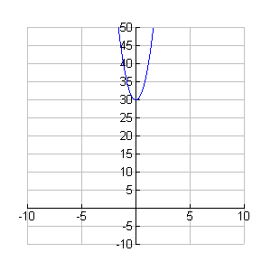

2(x2 – 3) = 8(x2 + 3)

5. How many real roots does this curve have?

Solve the equation for x.

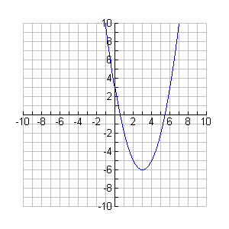

2(x – 3)2 = 8(x – 3)2 – 36

6. In parametric mode, how do you get this picture?

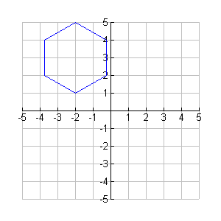

xT1 = Tmin =

yT1 = Tmax =

Tstep =

7. Find the heading and the distance you are from where you started. First you went N 78° E for 10 miles and then S 15° W for 16 miles.



8. A. Construct the altitude in ABC, from C to the line containing side AB   
 

9 C. Construct the inscribed circle of ABC   
 (intersection of the angle bisectors)



B. Construct the median in ABC, from C to side AB



D. Construct the circumscribed circle ofABC

(intersection of perpendicular bisectors)



10. Given a circle with center P



A. $\overline{BE}$ is a ___________

B. $\overline{AD}$ is a ___________

C. $\overset{⃡}{AE}$ is a ____________

D. $\overline{PA}$ is a ____________

E. $\overline{AX}$ is a ____________

F. $\hat{ED}$ is a __________ arc

G. $ADE$ is a __________ arc

H. ∠BEA is a __________

I. ∠EPD is a ___________

11. Plane E is tangent to sphere S at A. R is the midpoint of chord $\overline{BD}$, and P-R-A. Which of the following are true?



A. $\overline{PB}$ is a chord of the sphere

B. $\overline{PA}$ $≅$ $\overline{BD}$

C. $\overline{BD}$ ∥ plane E

D. $\overline{AD}$ is a chord of the sphere

E. Any line in E that contains A is tangent to S

F. $\overline{PD}$ is a radial segment of the sphere

G Except for A, every point of E is in the exterior of the sphere

12. P is the center of circle C, $\overline{PE}$ ⊥ $\overline{AB}$, PE = 3, PB = 6.   
 Find AB



13. AB is a diametric chord of the circle with center P. $\overline{AF}$ ∥ $\overline{PH}$, m∠A = 55° Find m and m

14. Find the center and radius of the circle whose equation is

x2 – 8x + y2 + 4y = 5

16. Which of the following are true?

A. If a diametral chord of a circle bisects a chord that in not a diameter, then the diametral chord is perpendicular to the other chord.

B. If the measure of an angle inscribed in a circle is 90 degrees, then the measure of its intercepted arc is 45 degrees

C In a circle two inscribed angles that intercept the same arc are congruent

D. Two concentric circles have at least one point in common

E. Any angle inscribed in a semicircle is a right angle

F. If the interiors of two spheres both contain a given point, then the intersection of the spheres is a circle

H. If two arcs of different circles have the same measure, then their chords are congruent

I Two concentric circles have at most one point in common

17. is a radial chord of the circle with center A. $\overline{BM}$ and $\overline{BD}$ are tangent to the circle. m $\hat{GM}$ = 84°, m $\hat{GF}$ = 58°, and m $\hat{DE}$ = 60°. Find the measure of the numbered angles.



18. An equation of a circle is x2 + y2 = 4

A. Find the value of a if D(a,1) is a point on the circle

B. Is the point R(2,3) on the circle? Why?

C. Is the point T( ) on the circle? Why?

19. Write an equation of the circle that has center P(-4,-3) and contains Q(-1,1)

20. Identify this figure. Find its center and radius

x2 – 12x + y2 + 14y + 4 = 0

21. Find the volume of a right circular cylinder if its height is 16m and the diameter of its base is 10m.

22. The volume of a circular cylinder is 600 m3 and its height is 3m. Find the diameter of the base.

23. If the radius of the base of a cone is 5m and its volume is 500 m3, find the height of the cone.

24. A spherical ball with diameter 5 cm has a hollow spherical center with diameter 2 cm. Find the volume of the solid shell.

25. The radius of the base of a cylindrical can is 12 cm and the height of the can is 20 cm. The can is filled with water and a sphere with radius 9 cm is thoroughly immersed in the can and then removed. Find the depth of the water remaining in the can.

26. The diameter of a spherical region is 12 cm.

A. Find the volume of the spherical region

B. Find the surface area of the spherical region

27. The radius of the base of a circular cone is 5 cm and the height is 6 cm. Find the area of the cross section 2 cm from the base.

28. Find the exact distance from (1,-1, 3) to (5,2,-1)

29. Write an equation for the sphere centered at (0,0,0) that contains the point (2,-1,1)

30. Give a three-dimensional open sentence that describes the set of all points that are 8 units from the point (1,-1,2)

31. Give an equation of the line passing through (1,-7) perpendicular to the graph of 5x – 3y = 23

32. Write an equation of the line that contains (5,9) and is parallel to the line that passes through (-2,3) and (5,8)

33. Write an equation of the line that passes through the origin and is perpendicular to the line described by y = 3

34. Write an equation of the line that passes through the origin and is perpendicular to the line described by y = x

35. Write an equation of the line that passes through (3,-7) and has slope -3

36. Solve for the common solution

24x + 56z – 13y = 965

85y + 33x – 43z = 563

45z – 37y + 12x = 342

37. Give the exact image of (9,-2) under a rotation of magnitude 90 degrees, centered at (0,0)

38. Give the exact image of (9,-2) under a rotation of magnitude -90 degrees, centered at (0,0)

39. Give the exact value (NO DECIMALS)

A. cos(45˚) B. sin(120˚) C. cos (-150˚)

D. sin(270˚) E. cos(315˚) F. sin(-30˚)

(You need to KNOW the unit circle!!!)

40.

|  |  |  |
| --- | --- | --- |
| Growth of Corn **(averages)** | Light  Low (-1) | Light  High (+1) |
| Water low (-1) | 2 cm | 4 cm |
| Water high (+1) | 6 cm | 12 cm |

A. Graph and find the **effect** of water

B. Graph and find the **effect** of light

C. Graph the water/light interaction

D. Find the interaction effect

41. Given the point with polar coordinates [3, 120˚ ] , give a polar name for this point such that:

A. r is positive and θ is positive

B. r is positive and θ is negative

C. r is negative and θ is positive

D. r is negative and θ is negative

42. Graph these points

A [4, 120° ]

B. [ -3, 210° ]

C. [ 2, - 45° ]

D. [ -5, - 300° ]



 

E. 2 + 3i

F. -4 + 5i

G. 3 – 4i

43. Give the polar coordinates for the point, (3, -4)

44. Give the rectangular coordinates for the point, [-6, 70˚]

45. Find the sum in rectangular notation:

[ 3, 90˚ ] + [ 5, 180˚ ]

46. Find the absolute value (magnitude)

A. [ 5, 36˚ ] B. [ -3, 177˚ ]

C. (3,4) D. 2 – 3i E. -3i

47. Give the following in a + bi notation:

A. (-1/2, 3/2) B. [ 1, -240˚ ]

C. (3 + 2i)(4 – 5i)

48. Find the sum and give in a + bi form

(3,-2) + (-1,4)

49. Give this product in polar form

[ 4, 20˚ ] [ 1.5, 80˚ ]

50. Find m  A



51. Find BC



52. Find BC



53. Find the solution in a + bi form

A. –i(-i)(-i) B. 33 – (2 + i)(3 – 5i)

C. (2 + 3i)2 D. (2 + 3i)3

54. Graph the following parent functions

A. y = x

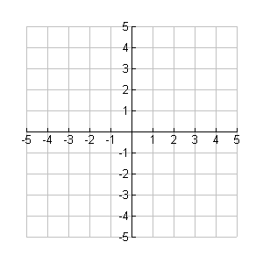

B. y = -x2



C. x2 + y2 = 1



D. y2 – x2 = 1



E. x = y2



F. xy = 1



55. Graph these equations

A. [image]



B. [image]



56. Write the equations for these graphs

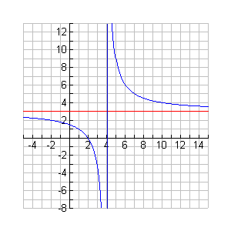

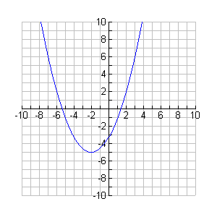

57. General Dynamics operates a plant that assembles and finishes both cars and trucks. It takes 5 man-days to assemble a truck, and 2 man-days to assemble a car; the finishing process requires 3 man-days for each car and truck that is produced. Because of manpower limitations, assembly can take no more than 180 man-days per week, and finishing no more than 135 man-days per week. If the profit on each truck is $300 and $200 on each car, how many of each should be produced to maximize profit.

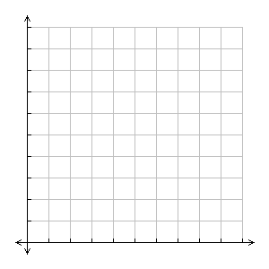



59. Graph these inequalities



y > 2x – 3



3x – 2y > 6



y > ½ x + 3 AND y < -3x + 4

60. Rotate (4,-5) 78 degrees around the origin

In addition, be prepared to compare and contrast concepts that we have gone over this semester.

Be sure to look at old quizzes and tests as a reference source.