Tower
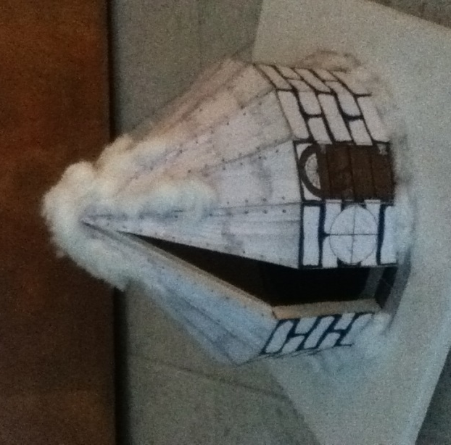

Matthew Polgar
9B GAT
Mr. Acre
5-31-13

Introduction
With all due respect, madam, I believe that you are one hundred percent nuts. That being said, it would be an honor to design your tower, Mrs. Copeland. As long as I’m not one of the poor men out working to build this thing, I have no problem designing it. I have only one question. Your letter included the words “vacation home” and “Antarctica” in the same sentence. Correct me if I’m wrong, but don’t people usually vacation in warmer climates, to relax? Not only that, but there’s nothing to do in Antarctica! You’d be completely cut off from the outside world!
I know it’s not my job to question your destination decisions, so don’t take this the wrong way. I just think you’re crazy.
But enough of that. You are offering a substantial amount of money to the one most capable of designing your tower, and I feel I’m up to the challenge. Your letter clearly states that you desire an “XXXXX tower, built upon a square plot of icy tundra twenty-seven feet in length.” You said that you want it to be “the maximum size possible, whilst remaining within the boundaries of buildable space and remaining perpendicular in some way shape or form to the available plot.” You want “an aquarium built into the flooring, strong foundations, and walls one foot in thickness.” You also presented multiple sizing requirements, as well as many other standards that must be met.
Your tower, Mrs. Copeland, is a daunting project. It will require every second of my time, every ounce of my effort, and every cell in my brain to complete. I sincerely hope that you are pleased by the end result.

The xxxxxxx Sided Polygon Maximized on the Plot

The polygon used for my tower is an xxxxxxxxxxx, or an xx-sided polygon. I have a plot that is 27 ft x 27 ft, but I am not allowed to build within 3 ft of the edge, per local rules. The tower will be built on foundations that are the same polygonal shape as the tower. The foundations must be the maximum size possible on the plot, without breaking any laws. Then, the tower will be 1 foot in from the foundation’s edge, and its walls will be 1 foot thick. Lastly, the foundations will end 1 foot inside of the wall’s inner edge.
When drawn out, this setup will create four concentric polygons, each exactly 1 foot further in than the last.
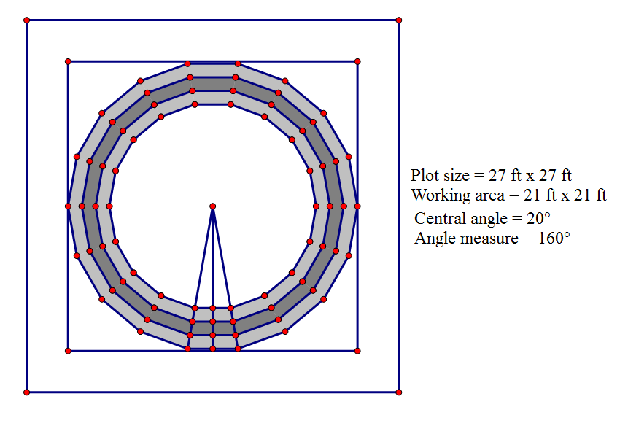
Figure 1. Aerial View of Polygons
Figure 1 shows the four necessary polygons, within the proper confines of the square. The original plot size was 27 ft x 27 ft, and nothing can be built within 3 ft of the edge of the plot. Therefore, the “working area” is 21 ft x 21 ft (27 minus 3 from each side: 27 – 6).
Seeing as how the polygons are 18-sided, the central angle must be 20 degrees (360/18). That means that each angle measure must be 160 degrees (180 – 20).
In order to maximize the outer polygon’s area, I have two of its vertices touching the “working area” square. This is correct because, had I had two sides touching, two of the vertices would be slightly outside of the “working area,” thus violating the local rules of Antarctica.
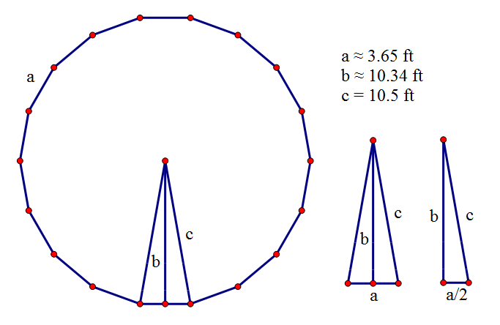
Figure 2. Outermost Polygon Measurements
Figure 2 shows the outermost octadecagon without its square border. Now, I must find its area. The first steps to that, however, are to find the side length of the octadecagon (a in Figure 2), and to find the height of each triangle that the octadecagon is split into (b in Figure 2).
sin(10) = (a/2)/10.5
10.5*sin(10) = a/2
21*sin(10) = a
a ≈ xxxx ft
Figure 3. Finding the Side of Polygon 1
Figure 3 shows the steps to find the side of Polygon 1, or the outermost polygon. The hypotenuse of the right triangle in Figure 2 (c), is equal to 10.5 ft because it is half of the side of the “working area,” since vertices are touching. The smallest angle in the right triangle is 10 degrees, because it is exactly half of 20 degrees. I used sine to find the approximate length of the side of Polygon 1.

cos(10) = b/10.5
10.5*cos(10) = b
b ≈ xxxx ft
Figure 4. Finding the Triangle Height of Polygon 1
Figure 4 shows the steps to finding the triangle height of Polygon 1. I simply used cosine to find the value that I needed to find.
A ≈ 18(1/2)(3.65)(10.34)
A ≈ xxxxx ft²
Figure 5. Finding the Area of Polygon 1
Figure 5 shows the simply process by which I found the area of Polygon 1. I simply took the area of the whole triangle in Figure 2, using ½(base)(height), and multiplied it by 18, since there are 18 of those triangles in my octadecagon. And so the area of the whole thing is about xxxxx ft². Please note that every rounded answer that was plugged into the equation was not calculated in rounded form. The exact answers for each number were used when finding the final solution. I just thought that it would be impractical to write down the exact value for every number that comes along in this paper. For future reference, every other value in the paper will be displayed in the same fashion.
One down, three to go!
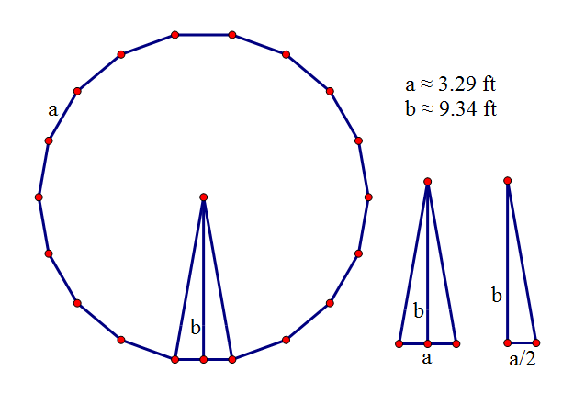
Figure 6. Second Outermost Polygon Measurements
Figure 6 displays the second outermost polygon, or Polygon 2, as well as the two triangles necessary for finding its area.
b ≈ 10.34 – 1
b ≈ 9.34 ft
Figure 7. Finding the Triangle Height of Polygon 2
Figure 7 shows the step used to find the triangle height of Polygon 2. Since each polygon must be scaled in exactly 1 foot from its predecessor, I merely had to subtract 1 from the previous triangle height in order to find the new triangle height.
tan(10) ≈ (a/2)/9.34
9.34*tan(10) ≈ a/2
18.68*tan(10) ≈ a
a ≈ 3.29 ft
Figure 8. Finding the Side of Polygon 2
Figure 8 displays the process used to find the side length of Polygon 2. I used the trigonometric ratio tangent to find the side length this time.
A ≈ 18(1/2)(3.29)(9.34)
A ≈ xxxxx ft²
Figure 9. Finding the Area of Polygon 2
Again, I found the area of the polygon by taking the area of one triangle and multiplying it by 18. The area turned out to be approximately xxxxx ft². Now it’s time for Polygon 3.
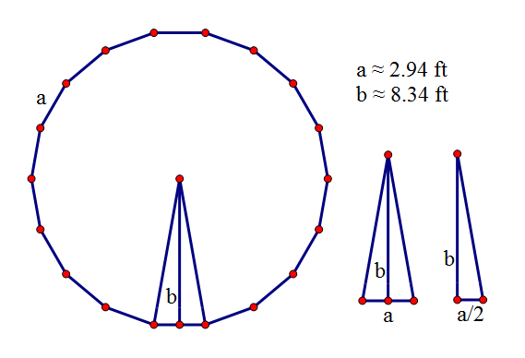
Figure 10. Second Innermost Polygon Measurements
Figure 10 displays the second innermost polygon, or Polygon 3, as well as the two triangles necessary for finding its area.
b ≈ 9.34 – 1
b ≈ 8.34 ft
Figure 11. Finding the Triangle Height of Polygon 3
Figure 11 shows how to find the triangle height of Polygon 3. Again, I just needed to subtract 1 from the previous height.
tan(10) ≈ (a/2)/8.34
8.34*tan(10) ≈ a/2
16.68*tan(10) ≈ a
a ≈ 2.94 ft
Figure 12. Finding the Side of Polygon 3
Figure 12 shows how to find the side of Polygon 3. Again, I used the trigonometric ration of tangent to accomplish my goal.
A ≈ 18(1/2)(2.94)(8.34)
A ≈ xxxxx ft²
Figure 13. Finding the Area of Polygon 3
The area of Polygon 3, found by multiplying the area of its triangle by 18, is found in Figure 13. It is about xxxxx ft². Now it’s time for the last polygon, Polygon 4.
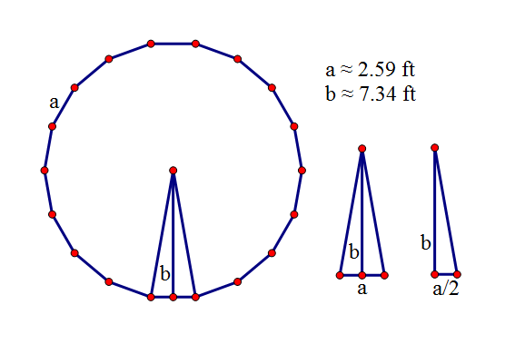
Figure 14. Innermost Polygon Measurements
Figure 14 displays the innermost polygon, or Polygon 4, as well as the two triangles necessary for finding its area.
b ≈ 8.34 – 1
b ≈ 7.34 ft
Figure 15. Finding the Triangle Height of Polygon 4
For the last time, Figure 15 shows how to calculate the height of the Polygon 4 triangle. I just subtracted another 1.
tan(10) ≈ (a/2)/7.34
7.34*tan(10) ≈ a/2
14.68*tan(10) ≈ a
a ≈ 2.59 ft
Figure 16. Finding the Side of Polygon 4
Figure 16 provides the steps to finding the side of Polygon 4. Once again, I used tangent to find the desired value.
A ≈ 18(1/2)(2.59)(7.34)
A ≈ xxxxx ft²
Figure 17. Finding the Area of Polygon 4
For the fourth and final time, Figure 17 shows how to find the area of Polygon 4. Just find the area of the triangle, and multiply it by 18. The area ends up being approximately xxxxx ft².

Volume of the Concrete Needed for the Footing and the Floor
My tower will have foundations that are the same shape as the tower itself. These foundations will be 3.5 ft deep and made of solid concrete, for maximum support. In addition, they will stretch all the way from Polygon 1 to Polygon 4. Contained within the foundations, or in Polygon 4, there will be an aquarium with many exotic species of fish (fish not included). The floor above this aquarium will be made of 4-inch Plexiglas, so that anyone walking above can view the fish below. The water in the aquarium will fill exactly 75% of the total volume within the foundations. I hope that, in the end, the effect will be quite pleasing.
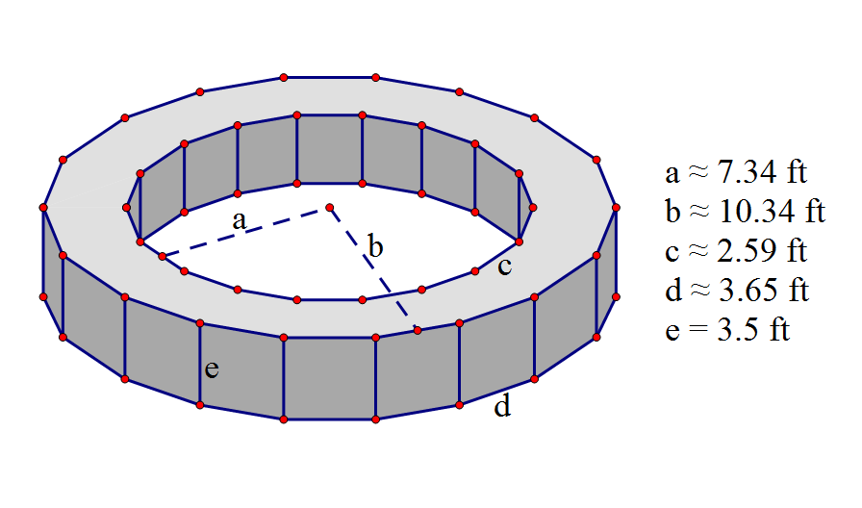
Figure 18. Foundations Diagram and Measurements
Figure 18 shows just the foundations of the tower. Now, I must find the volume of them. In order to do that, I need to figure out the area of the ring that the foundations are made in; the ring that stretches from Polygon 1 to Polygon 4. Then the volume will easily be found by multiplying that area by 3.5, since the foundations are 3.5 ft deep.
A ≈ 339.37 - 171.02
A ≈ xxxxxx ft²
Figure 19. Finding the Area of the Foundations
In Figure 19, I found the area of the ring that the foundations are made in. It was simple; all I needed to do was subtract the area of Polygon 4 (Figure 17) from Polygon 1 (Figure 5), which ended up being approximately 168.35ft². Now that I have this area, finding the volume will be extremely easy.
V ≈ 168.35(3.5)
V ≈ xxxxx ft³
Figure 20. Finding the Volume of the Foundations
Finding the volume of the foundations was a piece of cake. I simply took the area of that ring and multiplied it by 3.5, which is how deep the foundations will go. I got the volume of the foundations to be about 589.23 ft³.
Solid Concrete has agreed to give me a discounted price on their Uber-Ultra-Super-Fast-Drying-Extremely-Quick-Placement-Strongest-of-the-Strong-Concrete-Deluxe in order to build your tower. Each bag of Uber-Ultra-Super-Fast-Drying-Extremely-Quick-Placement-Strongest-of-the-Strong-Concrete-Deluxe contains exactly 1 cubic yard, and will cost $115.
So first things first, I need to know how many cubic yards of concrete I will need to lay the foundations. Currently, the volume is in cubic feet, so I need to convert it.
V ≈ 589.23/xx
V ≈ xxxxx yd³
Figure 21. Converting Cubic Feet Volume to Cubic Yard Volume
There are exactly xx ft³ for every 1yd³, so I just divided the volume of the foundations (in ft³) by xx in order to get the volume of the foundations in yd³. This volume turned out to be approximately xxxx yd³, which equates to xx bags of Uber-Ultra-Super-Fast-Drying-Extremely-Quick-Placement-Strongest-of-the-Strong-Concrete-Deluxe (since I obviously can’t buy partial bags). Therefore, the cost of concrete can be found easily.
C = xx*115
C = $xxxxx
Figure 22. Cost Analysis of the Foundations
By multiplying the number of bags of Uber-Ultra-Super-Fast-Drying-Extremely-Quick-Placement-Strongest-of-the-Strong-Concrete-Deluxe that I’ll need by the cost of one bag, I found the total amount of money that the foundations will cost. They will cost $xxxxx.
Now that that’s out of the way, it’s time to move on to the volume of the Plexiglas floor.
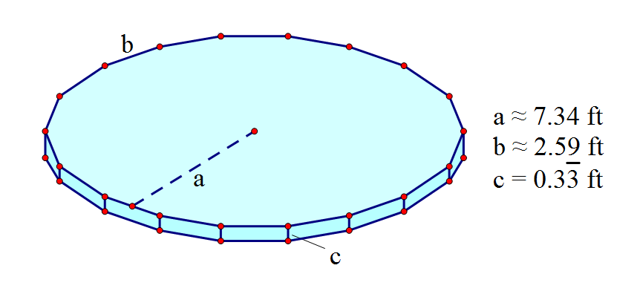
Figure 23. Plexiglas Diagram and Measurements
Figure 23 shows the Plexiglas floor. It is exactly 4 in thick, or 1/3 ft thick. Since it takes up Polygon 4, it has the same measurements as Polygon 4. I want to find the volume, and I have all the necessary measurements.
V ≈ (1/3)(171.02)
V ≈ xxxxx ft³
Figure 24. Finding the Volume of the Plexiglas Floor
To find the volume of the Plexiglas, all I needed to do was multiply the area of Polygon 4 (Figure 17) by 1/3, since the Plexiglas is 1/3 ft thick.
Transparent Plexiglas Co. has offered me a very fair price for their Extremely-Durable-and-Amazingly-Epic-High-Resolution-and-Ultra-Compact-Plexiglas-Stuff, which comes in sheets of 4 ft x 8 ft. The sheets are already 4 inches thick, so I won’t need to worry about thickness. Since each sheet is 4 x 8, that means that the area of one sheet is xx ft². Each of these sheets will cost $1,100. Now I need to figure out how many sheets I’ll need to complete the Plexiglas floor above the aquarium.
P ≈ xxxxx/xx
P ≈ xxxxx
P = xx sheets
Figure 25. Finding the Number of Plexiglas Sheets Necessary
I divided the total area of Polygon 4 by the area of one Plexiglas sheet in order to find the number of sheets I would need. Again, I rounded up because I can’t order partial sheets of Extremely-Durable-and-Amazingly-Epic-High-Resolution-and-Ultra-Compact-Plexiglas-Stuff.
C = xx*1100
C = $ xxxxx
Figure 26. Cost Analysis of the Plexiglas
I will order xx sheets, each $1,100, and so the amount of money I’ll spend on Plexiglas will be $ xxxxx.
Lastly, I want to figure out how much water will be in the aquarium, if it is 75% full.

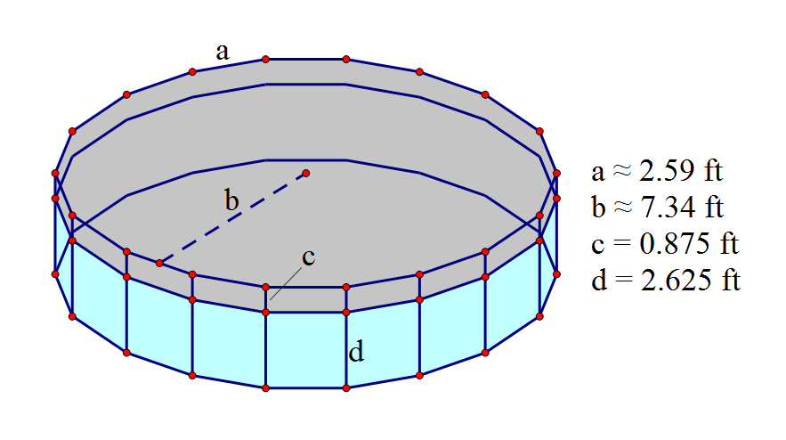
Figure 27. Aquarium Diagram and Measurements
My final task is to determine how much water I will fill the aquarium with, in order to ensure that it is 75% full. There are numerous ways in which I could accomplish this, but I choose the following:
I know that the entire height of the aquarium is 3.5 ft, since that’s how tall the foundations are. Also, I want the water to fill up ¾ of the aquarium. So, the height of the water level will be 2.625 ft (3.5*(3/4)). So to find the volume of the water, I just need to take the area of Polygon 4 and multiply it by 2.625.
V ≈ 171.02(2.625)
V ≈ xxxxx ft³
Figure 28. Calculating the Volume of the Water in the Aquarium
It’s as simple as that. I calculated the amount of water in the aquarium to be approximately xxxxx ft³.

One Lateral Face of the Outer Prism Base
Each of the 18 walls of my tower will be exactly twice as tall as they are wide. Since these walls are positioned on Polygon 2, I know that their width will be the same as the side length of Polygon 2.
Also, there will be one door and two windows on the tower. The door will be composed of a 5 ft x 3 ft rectangle as well as half of the xxxxxxx above the rectangle. Each window will have the same dimensions as the half-polygon above the door, except that they will be full polygons.
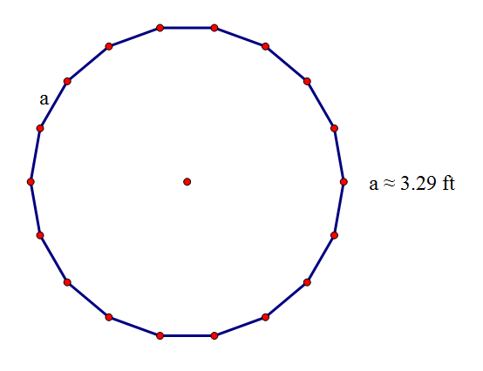
Figure 29. Polygon of the Outer Prism
Figure 29 simply displays Polygon 2, which is the polygon that the walls will be contained within. Each side of Polygon 2 is approximately 3.29 ft.
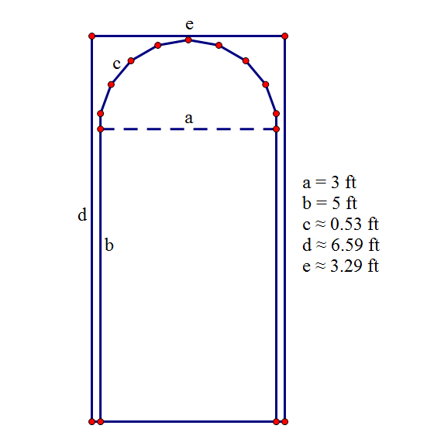
Figure 30. Lateral Face and Door Diagram and Measurements
Figure 30 clearly displays one lateral face of the outer prism of the tower. The dimensions of one face are 3.29 ft (the side of Polygon 2) by 6.59 ft (the side of Polygon 2 times 2, because each side must be twice as tall as it is wide). The door, on the other hand, had dimensions which are a bit trickier to find.
c = 2(1.5*tan(10))
c ≈ 0.53 ft
Figure 31. Finding the Side of the Top of the Door
First of all, we know that the apothem of the door top is 1.5, because the full length from one side to an opposite side must be 3 (to fit on the door). Doing this maximizes the area that the polygon-half can have, and also maximizes the height of the door. From there, simple trigonometric ratios were used to determine the length of one side of the polygon. The side of the polygon was calculated to be approximately 0.53 ft.

A ≈ 3(5) + (1/2)(18)(1/2)(0.53)(1.5)
A ≈ 15 + 3.57
A ≈ 18.57 ft²
Figure 32. Finding the Area of the Door
The area of the door was simple enough. All I had to do was add the area of the rectangle with the area of the half-polygon. The rectangle was simple enough; just base times height. The area of the polygon was found in the same manner as the area of the base polygons (Polygon 1, Polygon 2, etc.). The only difference is that I halved the answer I got, because only half of the polygon makes up the door. The total area of the door came out to be about 18.57 ft².
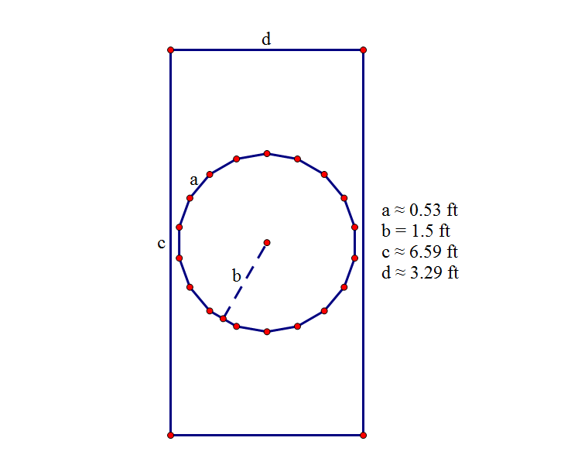
Figure 33. Lateral Face and Window Diagram and Measurements
The dimensions of the lateral face for the window are the same as the dimensions for the lateral face of the door, obviously. Also, the window has the same dimensions as the top of the door. This made further calculations extremely simple.

A ≈ 18(1/2)(0.53)(1.5)
A ≈ 7.14 ft²
Figure 34. Finding the Area of the Window
Since all the measurements were already found when finding the area of the door, all I had to do was plug the numbers in together. Again, I found the area of the polygon in the same fashion as all the other polygons. The area of the window is about 7.14 ft².
The last step is to find the lateral surface area of the entire bottom prism of the tower. Of course, I also need to subtract the areas for the door and the windows.
LSA ≈ 18(3.29)(6.59) – (18.57 + 2(7.14))
LSA ≈ 390.61 – 32.85
LSA ≈ xxxxxx ft²
Figure 35. Finding the Total Surface Area of the Outer Prism
I found the surface area of the prism by multiplying the width times the height for each side of the prism, and multiplying that value by eighteen. I then subtracted the values for the door and the two windows, to get a lateral surface area of approximately xxxxxx ft².

Volume of the Inner Base Prism
Now I want to find the volume of the inner prism. This prism can be described as the “air space” within the walls, and resides in Polygon 3.
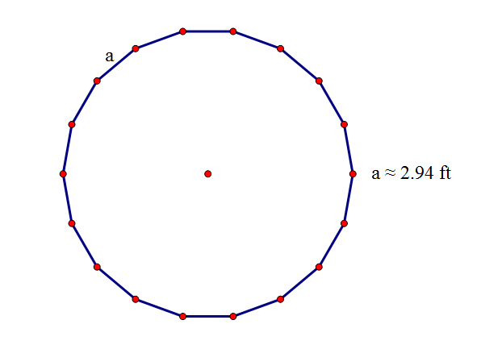
Figure 36. Polygon of the Inner Prism
Just as Polygon 2 was used for the outer prism, Polygon 3 will be used for the inner prism. It’s measurements were calculated previously; each side is approximately 2.94 ft.
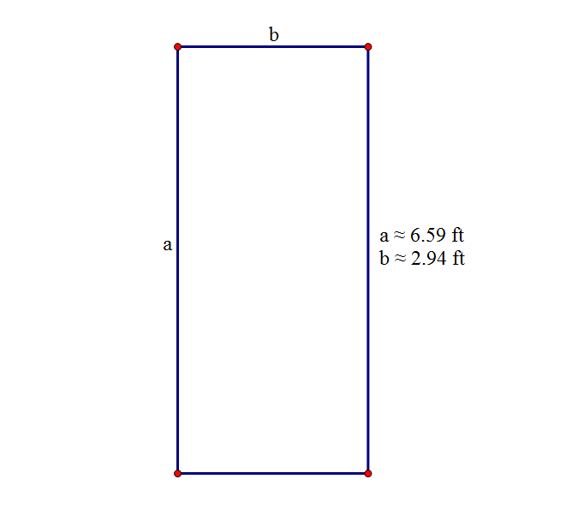
Figure 37. Lateral Face Diagram and Measurements
Figure 37 displays one lateral face of the inner pyramid. Its width is the same as the side length of Polygon 3 (because that is where the inner prism resides), and the height must be the same as the outer prism, otherwise the walls would slant and strange things would happen.
V ≈ 220.79(6.59)
V ≈ xxxxxxx ft³
Figure 38. Finding the Volume of the Inner Prism
To find the volume of the inner prism, I simply took the area of Polygon 3 (found in Figure 13) and multiplied it by the height, 6.59 ft. The total volume of the inner prism came out to be about xxxxxxx ft³.

Pyramid Top of the Outer Pyramid Showing the Height of the Outer Pyramid and the
Slant Height of One Lateral Face of the Outer Pyramid
Now it’s time for the roof of the tower. This will be made of a pyramid, with, again, the same number of sides as the base polygon. The height of this outer pyramid must be 3 times the length of one side of its base. This outer pyramid will reside in Polygon 2.
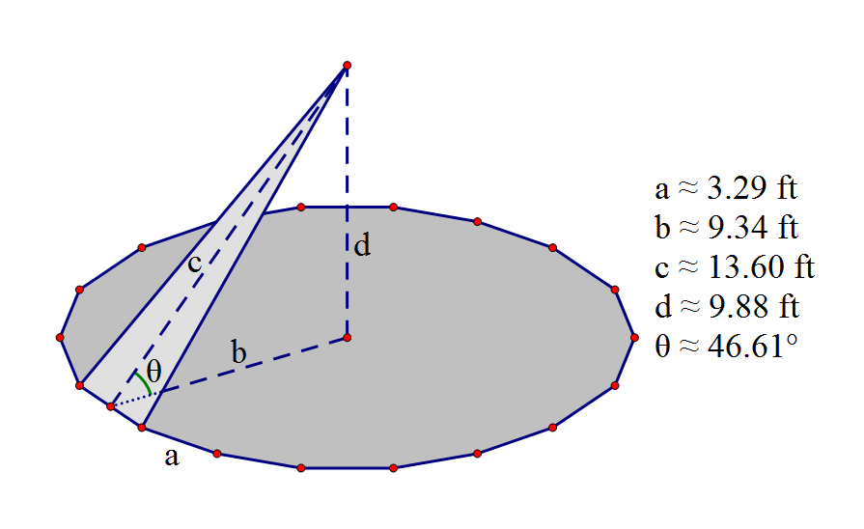
Figure 39. Outer Pyramid Diagram and Measurements
Figure 39 displays the base of the outer pyramid, as well as one of the lateral faces of the pyramid. Some of the measurements in Figure 39 area already known, such as a and b. These measurements have already been found when calculating the measurements of Polygon 2. The value for d can also be easily found by multiplying the side of the polygon (a) by 3, since the pyramid will be exactly three times as high as one side of its base. The last two values, c and θ, will take some calculations.
c ≈ √(9.34² + 9.88²)
c ≈ √(87.24 + 97.61)
c ≈ √184.85
c ≈ 13.60 ft
Figure 40. Finding the Slant Height of the Outer Pyramid
To find the slant height of the outer pyramid, I used the right triangle that is formed by the apothem of the base and the height of the pyramid. Using the Pythagorean Theorem, I was able to calculate the slant height as being about 13.60 ft.
θ ≈ tan⁻¹(9.88/9.34)
θ ≈ 46.61°
Figure 41. Finding the Angle Between the Prism Base and the Pyramid Face
Just out of curiosity, I wanted to figure out the angle between the prism outer prism base and the outer pyramid face. Using the trigonometric ratio of tangent, and turning that into inverse tangent, I was able to find that angle. It is approximately 46.61°.

One Lateral Face of the Outer Pyramid
Now that I have the necessary values, I need to find the lateral surface area of the outer pyramid, as well as a few other things.
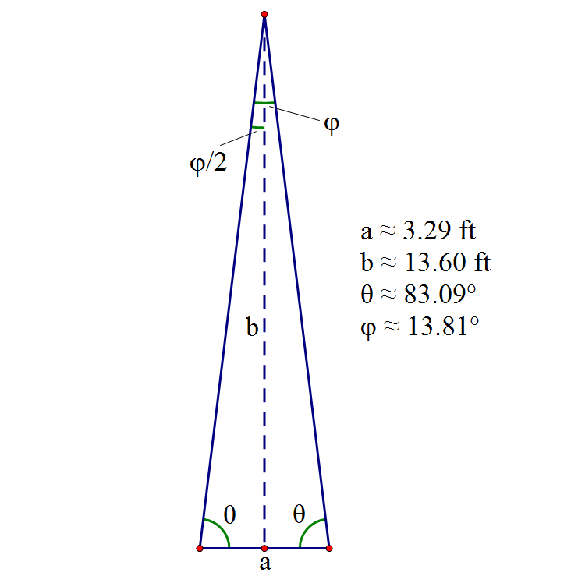
Figure 42. Diagram and Measurements of One Lateral Face
Both the base and the height of the triangular lateral face have already been found. However, the unknown angle measures should be calculated.
θ ≈ tan⁻¹(13.60/(3.29/2))
θ ≈ 83.09°
Figure 43. Finding the Base Angle of the Triangular Lateral Face
Using inverse tangent, as well as the measurements I found previously, I was able to calculate the base angles to be about 83.09°.
φ ≈ 2(tan⁻¹((3.29/2)/13.60))
φ ≈ 13.81°
Figure 44. Finding the Angle at the Top of the Triangular Lateral Face
Again, I used inverse tangent to figure out the last angle of the triangular face of the pyramid. Now that that’s out of the way, it’s time to calculate the lateral surface area.
LSA ≈ 18(1/2)(3.29)(13.60)
LSA ≈ xxxxx ft²
Figure 45. Finding the Lateral Surface Area of the Outer Pyramid
All I had to do to find the lateral surface area was find the area of one lateral face and multiply it by 18. The base of that face was 3.29 ft, and the height was 13.60 ft, making the lateral surface area approximately xxxxx ft².

Pyramid Top of the Inner Pyramid Showing the Height of the Inner Pyramid
The inner pyramid will reside in Polygon 3, just like the inner prism. Just like for the outer pyramid, the height of the inner pyramid must be three times the length of one side of its base. I need to find the volume of the inner pyramid.
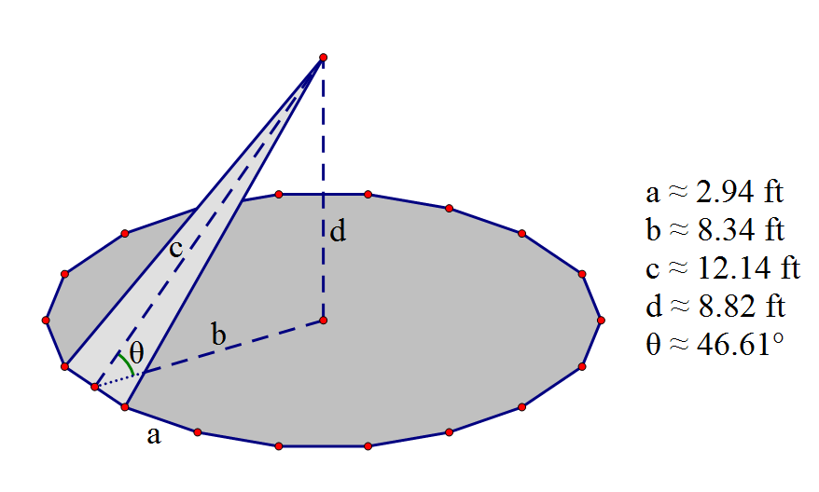
Figure 46. Inner Pyramid Diagram and Measurements
Once again, the measurements for the base of the pyramid, a and b, are the same as the measurements of Polygon 3. Finding the height, d, was a simple matter of multiplying a by 3.
V ≈ (1/3)(220.79)(8.82)
V ≈ xxxxx ft³
Figure 47. Finding the Volume of the Inner Pyramid
Using the volume of a pyramid formula: V = (1/3)(area of base)(height), I was able to find the volume of the inner pyramid. It came out to be approximately xxxxx ft³.

My Tower
So now everything is complete! Everything is calculated, and all that is left is to put it all together.
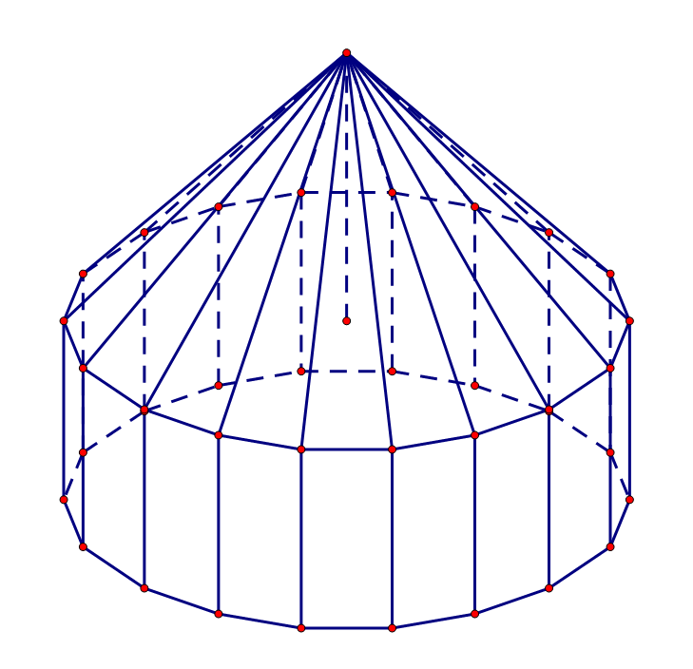
Figure 48. The Completed Tower
In Figure 48, you can clearly see the finished tower in all its glory. Now it’s time to find the total surface area and volume!

SA ≈ xxxxx + xxxxx
SA ≈ xxxxx
Figure 49. Calculating the Total Surface Area
In Figure 49, I simply added together the two surface areas found previously (in Figures 35 and 45). The total surface area of my tower is approximately xxxxx ft².
V ≈ xxxxx + xxxxx
V ≈ xxxxxxxx ft³
Figure 50. Calculating the Total Volume
In Figure 50, I simply added together the two volumes found previously (in Figures 38 and 47). The total volume of my tower is approximately xxxxxxxx ft³.

Conclusion
Throughout the course of these calculations, I encountered no issues. Everything went smoothly and exactly as planned.
I truly hope, Ms. Copeland, that you find my tower design to be pleasing. With 2,103.93 ft³ to work with, you could make a very spacious and elegant interior to your tower. Also, with 760.86 ft² of space to decorate outside of the tower, I’m sure you can come up with some wonderful decoration ideas (one of which I present to you on my scale model). Your tower will truly be the greatest tower in all of Antarctica!
With that, I will end this paper. I would be extremely grateful if you chose my tower design for yourself (along with giving me that plentiful amount of money in return). Thank you.

Sincerely,

