The Effects of Duration of Exposure and Distance from Ultraviolet Light on the Growth of *Escherichia coli*

Andrew Rouditchenko and Andrew Zannetti

Macomb Mathematics Science Technology Center

Biology 1 – 9B

Mr. Estapa, Mrs. Duddles, Mr. Acre

May 24, 2012

Table of Contents

Introduction 2

Problem Statement 6

Experimental Design 7

Data and Observations 14

Data Analysis and Interpretation 19

Conclusion 26

Acknowledgements 30

Works Cited 31

**Introduction**

Food is one of the most important resources of mankind. Food poisoning is a very serious matter that may affect large populations very quickly. Of the several microbes responsible for these epidemics, *Escherichia coli* (E. coli*)* is one of the most common (Aguiar, et al.). Outbreaks of these bacteria can happen anywhere, even in countries with high standards of hygiene. To protect the health of humans and to ensure the quality of food, different methods have been developed for killing the bacteria.

*Escherichia coli* is a very common type of bacteria. There are many different strains, or types of the bacteria. Many of these strains live symbiotically with humans and animals. For example, 0.1% of an adult’s intestines are represented by E. coli(Brown). There are a few strains of the bacteria that are harmful. If a person is infected by one of these strains, they can develop kidney failure, lose red blood cells, and develop other effects.

E. colireproduce by means of conjugation and cellular division (Hamlako and Swenson). Both of these methods use the DNA of the cell. To kill the cells, the DNA would have to be altered somehow to prevent replication. E. coligrows optimally at 37° Celsius (Nguyen), which is the mean temperature of many mammals.

Several methods have already been developed and recognized to kill bacteria. Two of these methods are ultraviolet sterilization and heat sterilization (Aguiar, et al.). Many believe that ultraviolet sterilization is more useful and effective than heat because heat will spoil food, which often carries the harmful bacteria.

Ultraviolet light is the area on the electromagnetic spectrum ranging from 190 to 410 nm in wavelength (“Hazards of Ultraviolet Light”). Ultraviolet light is invisible to the naked eye and is harmful to human skin and eyes. The wavelength of UVa, or near UV, ranges from 190 -290 nm in wavelength. The shorter the wavelength, the more energy a light wave has. Also, when the wavelength of the light wave is short, the intensity is high. The intensity of a light wave can be defined as the number of photons (McMillan).

The maximum absorption rate of the DNA of E. coliis about 254 nm. This means that when the wavelength of the ultraviolet light is in the UVa range, the DNA of the bacteria absorbs the most photons. Photons from UV light create dimers in the DNA that break the chemical bonds and prevent replication (Aguiar, et al.). If the duration of exposure is not long, the photons have not created too many dimers and the bacteria deploy repair mechanisms that fix the DNA strand. As the duration increases, more dimers are created and the repair mechanisms can not keep up. The cell of the bacteria can not replicate and therefore dies.

The objective of this experiment is to find the optimum combination of the duration of time exposed to an UVa light source and the distance away from the light to kill E. coli. Researchers already have proven that the longer that E. coli is exposed to ultraviolet light, more cells die, but no one has focused on the distance from the ultraviolet light. The results could be used in places where food or anything is handled by humans and sterilize these areas. The data could also be used to analyze the most cost efficient way to sterilize something. For example, a company could use the data to find out what the maximum time they should leave the light on for – if all the E. colidies after a minute of exposure and they leave the light on for 5 minutes, they could be losing money for electricity.

The response variable that will be counted in the experiment is the number of E. colicolonies. A colony is a group of E. colicells that grow together. Colonies are represented by a small beige dot. Sometimes the colonies grow together in large patches which are called lawns and the counting methods will be adjusted to approximate the number of colonies.

The first variable that will be tested is the duration of time exposed to the ultraviolet light. The ultraviolet light is germicidal, or in the UVa wavelength range. As the duration of time increases, the amount of colonies should decrease because more photons are absorbed by the DNA of the bacteria and therefore more cells will die because they are not able to replicate.

The second variable that will be tested is the distance away from the ultraviolet light. According to physics teacher Mr. McMillan, as the distance from the ultraviolet light increases, the amount of colonies should increase. This is because the intensity of the ultraviolet light waves, or the number of photons decreases as the distance from the ultraviolet light increases in accordance to the inverse square law ("Inverse Square Law"). The inverse square law states that as the distance doubles from a light source, the intensity reduces to 25% of its original state, so the number of photons decreases drastically as the distance increases.

Throughout the experiment, E. coliwill be grown and exposed to ultraviolet light. E. coli will be transferred to Petri dishes with nutrient agar and they will then be subjected to an ultraviolet light in a goggle sterilization cabinet. The Petri dishes will be grouped and exposed for different amounts of time and different distances and then they will be placed in an incubator. After the incubation period, the number of colonies for each dish will be counted and recorded, and any observations will be recorded.

**Problem Statement**

Problem:

What is the effect of the duration of ultraviolet light exposure and the distance from the light source on the growth of *Escherichia coli*?

Hypothesis:

If *Escherichia coli* is exposed to ultraviolet light for a long amount of time, and the distance from the light source is short, then less colonies will grow than *Escherichia coli* that is exposed to ultraviolet light for a short amount of time and the distance from the light source is further away.

Data Measured:

The two independent variables are the distance from the ultraviolet light source measured in centimeters and the duration of exposure to the ultraviolet light in minutes. The dependent variable is how many colonies will grow in one Petri dish. The statistical method that will be used to analyze the data is the two-factor Design of Experiment (DOE).

**Experimental Design**

Materials:

500 g Carolina nutrient agar

1 gallon sterile distilled water

1 lL flask

Sellstrom Model 2000 Ultraviolet Cleaning Cabinet

(75) 100 mm x 15 mm Carolina styrene disposable Petri dishes

Baxter Tempcon incubator (37°C)

11° Celsius refrigerator

smart phone stopwatch application

Sartorius Analytic electronic balance

(4) 4” by 5” sheets paper

5 cm teflon stirring magnet

Corning stirrer/hot plate

*Escherichia coli* starter plate

sterile transfer loop

(8) Pyrex sterile test tubes

(4) 1 ml Carolina transfer pipets  
 rubber hot mitt

Bunsen burner

Scotch masking tape

metric ruler

15”x 3” x 8” cardboard box

calculator

large scissors

Sharpie marker

striker

Procedure:

Preparing the Sellstrom Model 2000 cabinet:

1. Cut 5 cardboard pieces that are 45cm x 11cm from the 15”x 3” x 8” cardboard box.

2. Place each cardboard piece on a shelf in the Sellstrom Model 2000 cabinet.

3. Secure each piece of cardboard to each shelf using Scotch masking tape.

4. Using the metric ruler and the Sharpie marker make one tick mark in front of the bulb, one 12 cm, and one 24 cm to the right of the bulb.

Preparing the agar:

1. Turn on the hot plate and set the heat to high.

2. Pour 500 ml of sterile distilled water into a 1 flask.

3. Make a crease ion the middle of a 4” by 5” paper sheet.

4. Place the sheet of paper on the electronic balance.

5. Pour 11.5 g of agar onto the sheet of paper from the Carolina nutrient agar bottle.

6. Remove the sheet of paper from the balance, be careful not to allow any agar to spill.

7. Carefully lower the stirring magnet into the solution in the flask.

8. Place the flask onto the hot plate and turn on the stirring feature, set the speed to 4.

9. Pour agar into the 1 liter flask filled with 500 ml of water.

10. When the agar solution becomes clear like apple juice, remove the flask from the Corning Stirrer/Hot Plate using the rubber hot mitt. Be sure to turn off both the heat and the stirrer. Refer to Figure 1.

11. Allow the agar to cool for at least 5 minutes.

12. Repeat for every four trials that are conducted.

Preparing the Petri dishes:

1. Label 4 100 mm x 15 mm Petri dishes with name, date, and (+,+).

2. Label 4 Petri dishes with name, date, and (+,-).

3. Label 4 Petri dishes with name, date, and (-,+).

4. Label 4 Petri dishes with name, date, and (-,-).

5. Label 4 Petri dishes with name, date, and standard.

6. Clam open the top of each Petri dish from all of the groups and pour the stirred

agar solution with just enough to fill the bottom of the Petri dish. Be sure to use the rubber hot mitt to handle the flask. Be careful to not get any bacteria in the dish, do not cough, talk, etc.

7. Place the cover of each Petri dish back on. Wash out the 1 liter flask with hot tap water.

8. Allow the agar to cool for 20 minutes or until the agar solidifies.

9. If storing the Petri dishes for later use, invert them and place in the 11° Celsius

refrigerator.

10. Repeat for every four trials that are conducted.

Inoculating the Petri dishes:

1. Using the 1 ml Carolina transfer pipet, transfer 10 ml of sterile distilled water into a sterile test tube.

2. Repeat step 1 with another sterile test tube.

3. Connect a Bunsen burner to a gas outlet.

4. Turn the handle of the gas outlet to the on position.

5. Using the striker, start the Bunsen burner.

6. Take the transfer loop and pass the loop and top of the neck through the flame to sterilize it. Refer to Figure 2.

7. Open the top cover of the *Escherichia coli* starter plate and slide the sterile transfer loop across the surface to get a sample. Refer to Figure 3.

8. Take the sample of Escherichia coli and dip it into the first Pyrex sterile test tube. Refer to Figure 4.

9. Repeat steps 6-8 with the other Pyrex sterile test tube.

10. Take the top cover off of each Petri dish of each group and pour just

enough of the *Escherichia coli* solution (about 1 ml) from the Pyrex sterile test tube to cover the top.

11. Place the cover of each Petri dish back on.

12. Lightly shake the Petri dishes to ensure that the E. coli solution covers the entire surface of the agar.

13. After about one minute open the Petri dishes and empty the excess E. coli solution into a sink.

Experiment:

Table 1

Design of Experiment Factors

|  |  |  |  |  |  |
| --- | --- | --- | --- | --- | --- |
| Duration (minutes) | | | Distance (cm) | | |
| (-) | (S) | (+) | (-) | (S) | (+) |
| 1:30 | 2:00 | 2:30 | 24 | 12 | 0 |

Table 1 above shows the setup of each trial. The duration in minutes is the amount of time that the *Escherichia coli* is exposed to ultraviolet light. The distance in centimeters is the distance of each Petri dish from the ultraviolet bulb.

1. Take the 4 Petri dishes of the (-,+) group and place them near the Sellstrom Model 2000.

2. Carefully place each Petri dish on a different shelf on the tick mark directly in front of the bulb.

3. Take the Take the 4 Petri dishes of the (-,-) group and place them near the Sellstrom Model 2000.

4. Carefully place each Petri dish on a different shelf on the tick mark 24 cm to the right of the bulb.

5. Open the cover of each Petri dish and place it near the other portion of the Petri dish on the same shelf.

6. Turn on the smart phone and get the stopwatch application ready.

7. Set the timer on the side of the Sellstrom Model 2000 cabinet to 5 mixtures.

8. Close the cabinet, lock the swinging door, and begin the stopwatch application. The ultraviolet light turns on as soon the door is closed, and it turns off as soon as the door is opened.

9. After exactly one minute and thirty seconds, unlock the swinging door and open up the Sellstrom Model 2000 cabinet.

10. Put the cover of each Petri dish back on.

11. Stack the Petri dishes of the (-,+) group on top of each other and the Petri dishes of the (-,-) group together.

12. Invert the two stacks and place them in the incubator, set the temperature to 37ºC.

13. Take the 4 Petri dishes of the (+,+) group and place them near the Sellstrom Model 2000 cabinet.

14. Carefully place each Petri dish on a different shelf on the tick mark directly in front of the bulb.

15. Take the Take the 4 Petri dishes of the (+,-) group and place them near the Sellstrom Model 2000 cabinet.

16. Carefully place each Petri dish on a different shelf on the tick mark 24 cm to the right of the bulb.

17. Open the cover of each Petri dish and place it near the other portion of the Petri dish on the same shelf.

18. Set the timer on the side of the Sellstrom Model 2000 cabinet to 5 minutes.

19. Close the cabinet, lock the swinging door, and begin the stopwatch application.

20. After exactly two minutes and thirty seconds, unlock the swinging door and open up the Sellstrom Model 2000 cabinet.

21. Put the cover of each Petri dish back on.

22. Stack the Petri dishes of the (+,+) group on top of each other and the Petri dishes of the (+,-) group together.

23. Invert the two stacks and place them in the 37°C incubator.

24. Take the 4 Petri dishes of the standard group and place them near the Sellstrom Model 2000 cabinet.

25. Carefully place each Petri dish on a different shelf on the tick mark 12 cm to the right of the bulb.

26. Close the cabinet, lock the swinging door, and begin the stopwatch application.

27. After exactly two minutes, unlock the swinging door and open up the Sellstrom Model 2000 cabinet.

28. Put the cover of each Petri dish back on.

29. Stack the Petri dishes of the standard group on top of each other.

30. Invert the stack and place it in the 37°C incubator.

Data Collection:

1. Make a data table that includes group and the amount of colonies found in each Petri dish.

2. After approximately 24 hours remove all of the Petri dishes from the 37°C incubator.

3. Record the number of *Escherichia coli* colonies that are found in each Petri dish.

4. After all of the colonies for each Petri dish have been counted, carefully stack the Petri dishes in their respective groups and place them in the garbage bin.

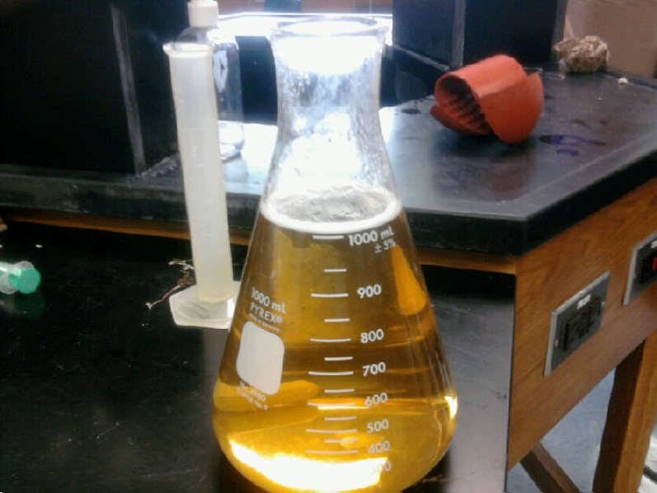

Figure 1. Stirred Agar Solution

Figure 1 above shows the stirred agar solution that is ready to be poured into the Petri dishes.

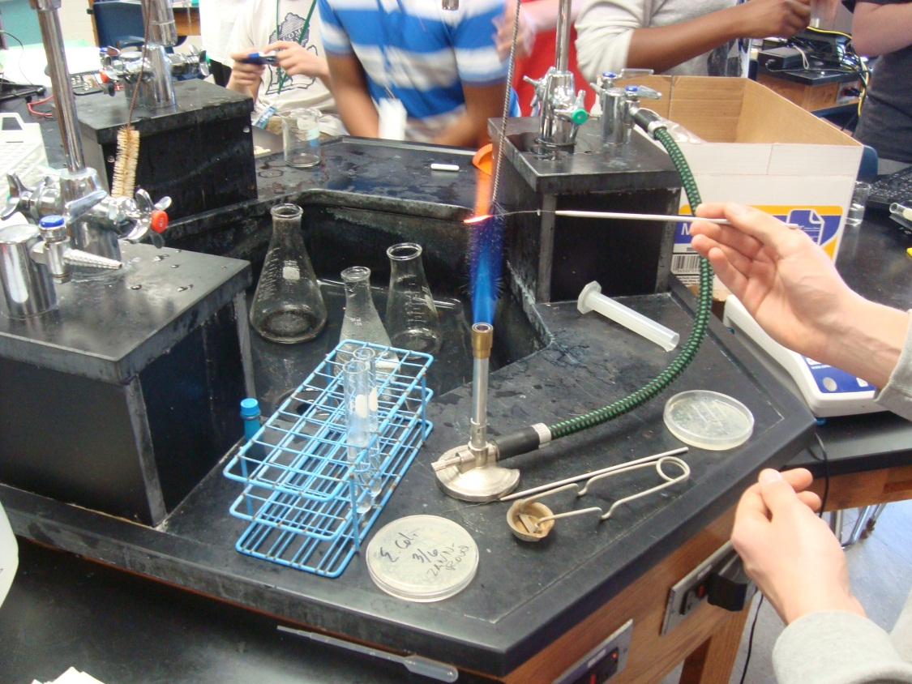

Figure 2. Sterilizing the loop

Figure 2 above shows the sterilization of the loop used to transfer *Escherichia coli*. The red tip of the loop is being sterilized.

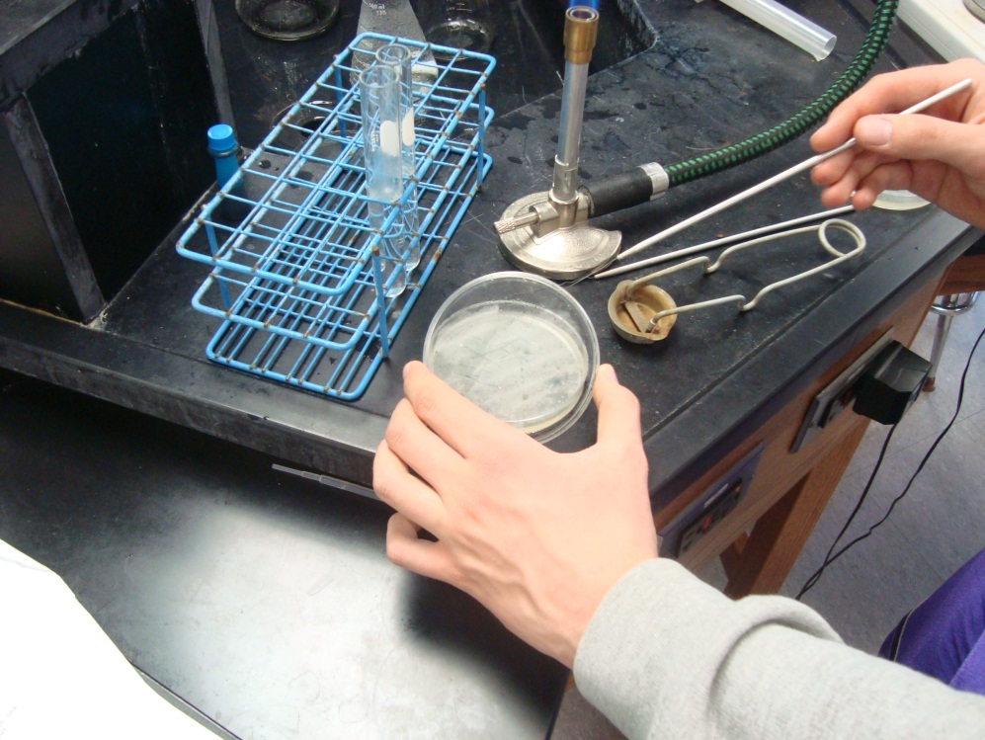

Figure 3. Collecting an *Escherichia coli* Sample

Figure 3 above shows the collection of an *Escherichia coli* sample from the starter plate. The very end of the sterile loop is rubbed along the top of the *Escherichia coli* that has grown on top of the agar.

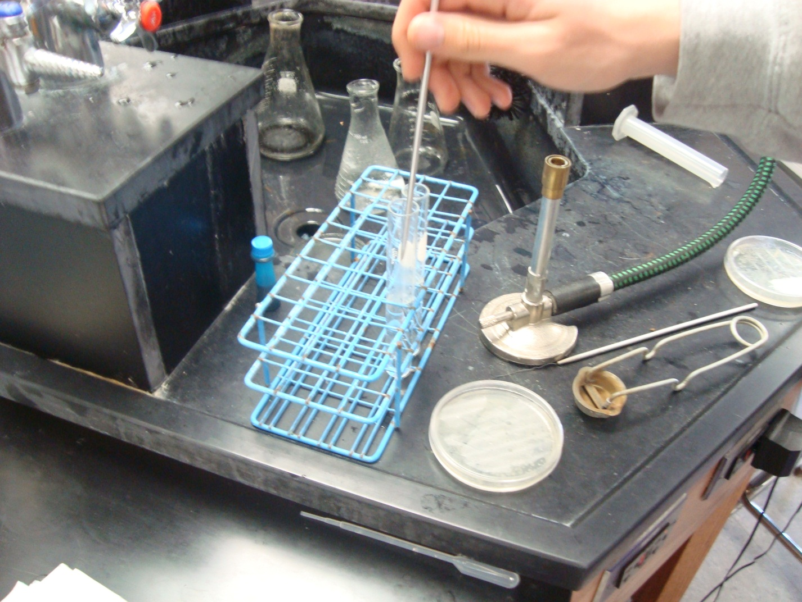

Figure 4. Inoculating the Test Tubes

Figure 4 above shows the inoculation of the Pyrex sterile test tubes. The sterile loop with the *Escherichia coli* sample is being dipped into the first sterile test tube.

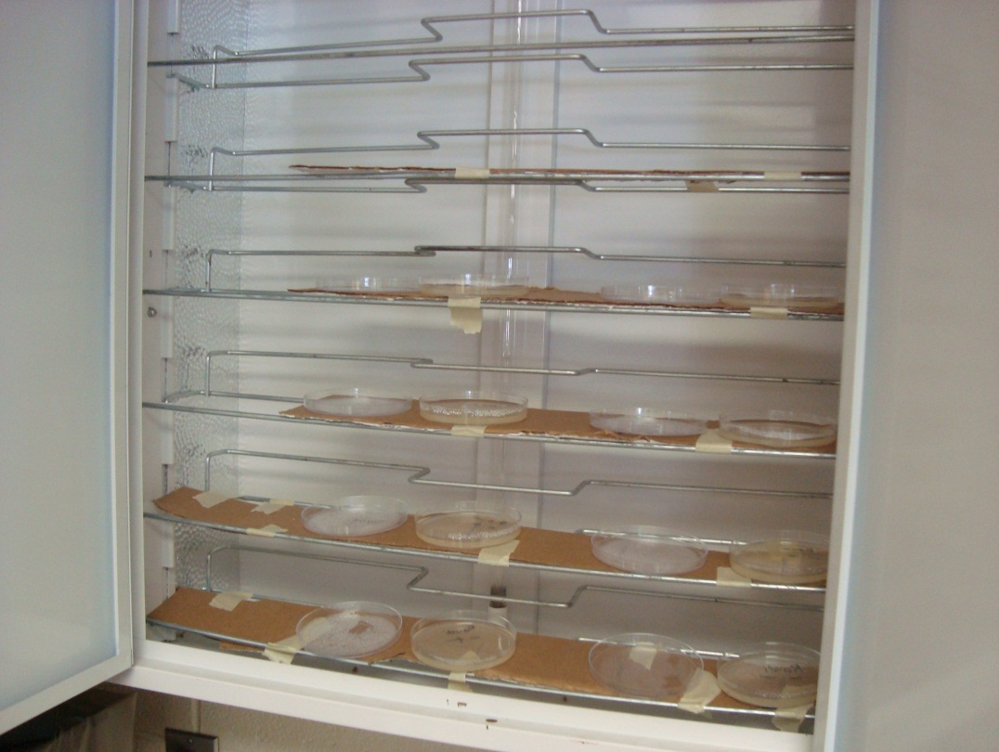

Figure 5. Sellstrom Model 2000 Ultraviolet Light

Figure 5 above shows the shelves of the Sellstrom model 2000. The ultraviolet bulb is in the center of the cabinet. Notice that there are four Petri dishes for each group. The covers of the Petri dishes are placed next to each Petri dish. The Scotch masking tape is used as support for the shelves.

**Data and Observations**

Table 2

Design of Experiment Factors

|  |  |  |  |  |  |
| --- | --- | --- | --- | --- | --- |
| Duration (minutes) | | | Distance (cm) | | |
| (-) | (S) | (+) | (-) | (S) | (+) |
| 1:30 | 2:00 | 2:30 | 24 | 12 | 0 |

Table 2 above shows the setup of each DOE. The duration in minutes is the amount of time that the *Escherichia coli* is exposed to ultraviolet light. The distance in centimeters is the distance of each Petri dish from the ultraviolet bulb.

Background research that was done before the experiment found that in a previous experiment with a similar ultraviolet light, no E. coli grew after two minutes of exposure (Beck). During pre-trials, it was found that E. coli grew very densely after one minute of exposure to the ultraviolet light, so it was not possible to count the number of colonies. After three minutes of exposure, no colonies grew, so it was decided that the numbers for the amount of duration should be between the threshold of unlimited growth and complete death.

During research, it was found that in each of the other experiments the distance from the ultraviolet light was kept constant. The standard in the pre-trials was 9 cm which was based off another experiment (Hamlako and Swenson). During pre-trials, it was found that 4 cm variability did not change the growth of the E. coli, so it was decided to have 12 cm of variability.

Table 3

Raw Data

|  |  |  |  |  |  |
| --- | --- | --- | --- | --- | --- |
| **DOE** | **Number of Colonies** | | | | |
| **Duration of Exposure (minutes), Distance (centimeters)** | | | | |
| **(+,+)** | **(+,-)** | **(-,+)** | **(-,-)** | **Standard** |
| 1 | 36 | 98 | 84 | 214 | 71 |
| 2 | 89 | 63 | 78 | 200 | 96 |
| 3 | 48 | 140 | 122 | 217 | 83 |
| 4 | 44 | 191 | 58 | 210 | 98 |
| 5 | 55 | 223 | 187 | 213 | 86 |
| 6 | 205 | 180 | 99 | 286 | 95 |
| 7 | 60 | 176 | 54 | 234 | 102 |
| 8 | 89 | 210 | 83 | 244 | 101 |
| 9 | 78 | 198 | 168 | 238 | 86 |
| 10 | 94 | 189 | 65 | 207 | 97 |
| 11 | 140 | 217 | 67 | 238 | 103 |
| 12 | 103 | 215 | 56 | 262 | 98 |
| 13 | 86 | 189 | 136 | 180 | 87 |
| 14 | 54 | 149 | 49 | 232 | 94 |
| 15 | 123 | 131 | 67 | 286 | 91 |

Table 3 above shows the number of colonies collected during the experiment over time. There were fifteen trials conducted. Three trials were run the first day and four trials were run each other day. There was significant variability between all of the data collected for each group. Each number represents the number of E. coli colonies.

Table 4

Daily Observations

|  |  |
| --- | --- |
| Date | Daily Observations |
| 3-19-12 | Agar was adjusted for three DOEs. The bare minimum was poured for each Petri dish. The dishes were inverted and placed in the refrigerator. |
| 3-20-11 | After pouring the E. coli solution into the Petri dishes there was not enough for one Petri dish. E. coli solution was poured from a different dish that had an excess amount. During trials the timer kept resetting to zero and this may have caused duration times to not be exact. Agar was made for 4 DOEs. The Petri dishes were inverted and placed in the refrigerator. |
| 3-21-12 | First day of data collection- Small round colonies were counted individually and large colonies were subdivided to be counted. Some outer rings of the Petri dishes were completely covered, this was counted as 80 colonies. One Petri dish had excess water on the surface of the agar. Several Petri dishes taken from the refrigerator had condensation on the covers. Agar was poured for 4 DOEs, inverted then placed in the refrigerator. |
| 3-22-12 | Many Petri dishes taken from the refrigerator had condensation on the covers. Data patterns seemed consistent with the data from the day before. However, the numbers for the colonies were much higher. No agar was made. |
| 3-23-12 | Agar was poured for 4 DOEs, inverted then placed in the refrigerator. The data was collected and the number of colonies were consistent with the previous data. |
| 3-26-12 | 4 DOEs were inoculated with E. coli solution. During the standard trial the light may not have turned on. No agar was made. |
| 3-27-12 | The 4 DOEs had their colonies counted. The standard was consistent with the previous data, our doubts had been proven wrong. All unnecessary materials were disposed of. |

Table 4 above shows the observations that were recorded each day during trials.

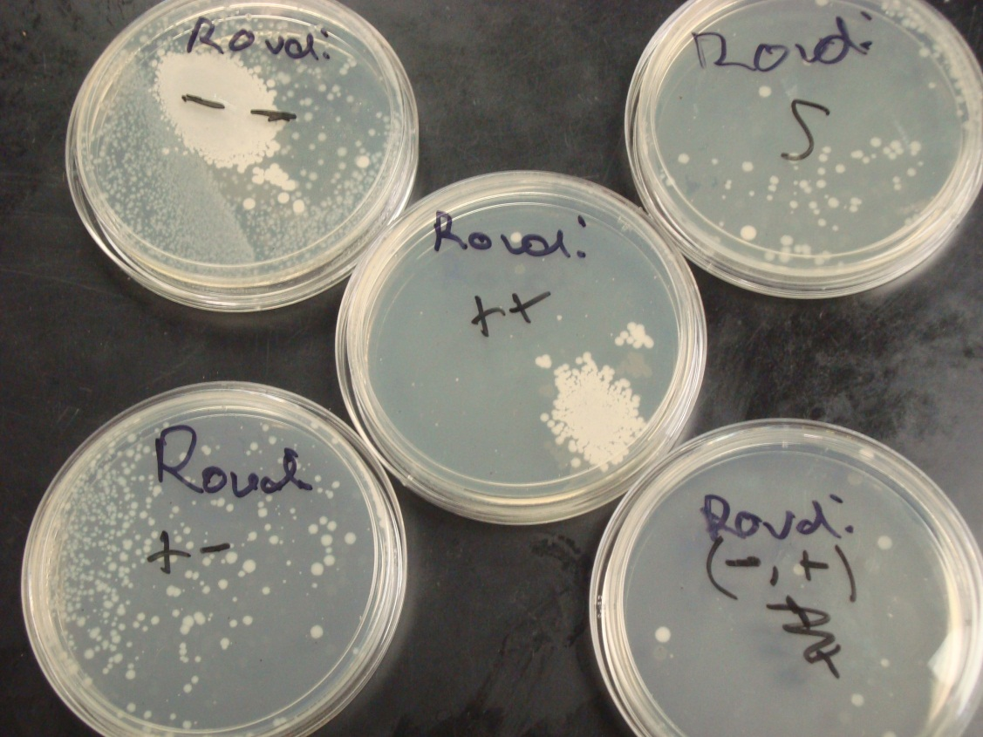

Figure 6. Petri Dish Samples

Figure 6 shows the Petri dishes from DOE 7. The concentration and the amount of colonies is different in each dish. The top left (-,-) dish has the most E. coli colonies. The bottom right dish (-,+) has the least amount of colonies. However, the (-,+) group did not always have the least amount of colonies. The (+,+) group, on average, had the least amount of colonies. The (-,-) group, on average, had the most amount of colonies.

While collecting data it was noticed that the (+,+) and (-,+) groups had similar data. The data found for the (-,-) and (+,-) groups was also similar. From this observation it can be inferred that light intensity, or the distance away from the light is an important effect, while the duration exposed to the light has less of an effect.

A colony is a small beige circle. Every separate dot is considered a colony. Refer to Figure 7. Due to the fact that the bacteria colonies often grew together in lawns as shown in Figure 8, counting methods were used as described in the procedure. Separate colonies were counted individually. It was found that an average colony is approximately 0.25 cm2 in area. When there was a lawn or group of colonies, the area of the group was found and divided by the 0.25 cm2. If the entire outer ring was covered it was counted as 100 colonies (the circumference of the Petri dish is about 26 cm).

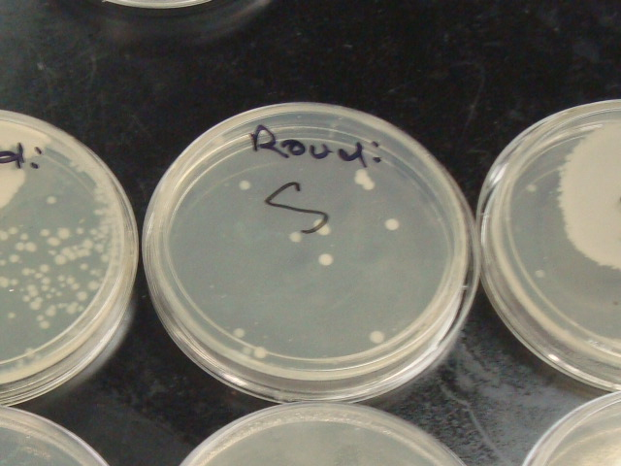

Figure 7. Regular *Escherichia coli* Colony

Figure 7 above shows normal colonies of *Escherichia coli*.

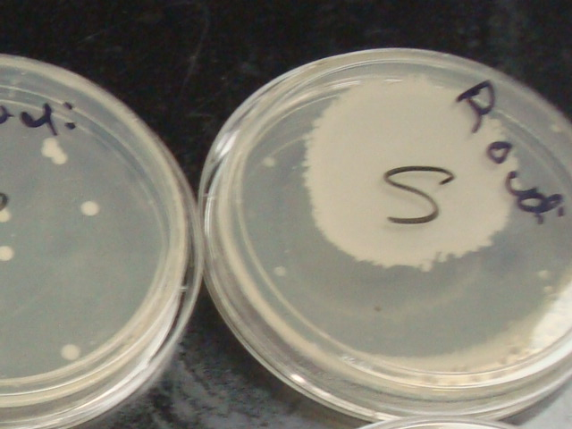

Figure 8. Irregular *Escherichia coli* Colony

Figure 8 shows a large irregular *Escherichia coli* colony otherwise known as a lawn. To find how many colonies there exist in such a lawn, the approximate area of the lawn was found and divided by the average size of a colony, or 0.25 cm2.

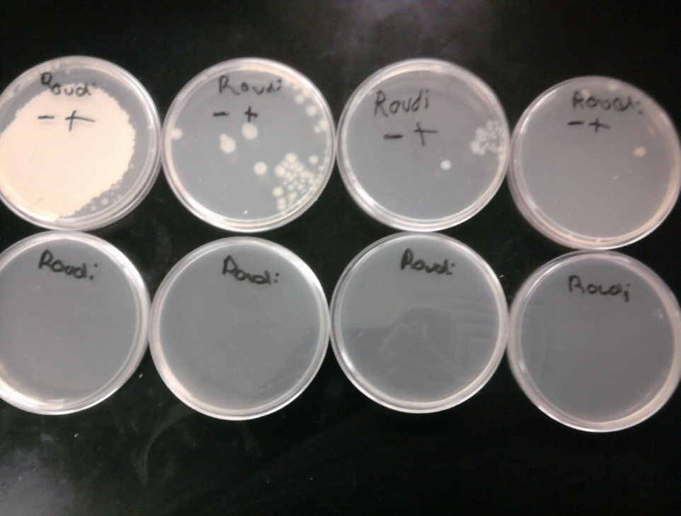

Figure 9. Before and After Comparison

Figure 9 above shows the before and after comparison of the Petri dishes of the

(-,+) group that have been exposed to ultraviolet light and the Petri dishes that just have agar in them. As can be seen by Figure 9 there is a lot of variability between the dishes in the top row which have already been subjected to the ultraviolet light and E. coli*.*

**Data Analysis and Interpretation**

Table 5

Averages

|  |  |  |  |  |  |
| --- | --- | --- | --- | --- | --- |
|  | (+,+) | (+,-) | (-,+) | (-,-) |  |
| Average | 86.9333333 | 171.266667 | 91.5333333 | 230.733333 |  |
| Grand Average |  |  |  |  | 145.117 |

Table 5 above shows the approximate averages of colonies that were found for each group. The (+,+) group had the lowest average and the (-,-) group had the highest. The grand average of the experiment was about 145 colonies of E. coli.

|  |  |
| --- | --- |
| UV Exposure Duration (minutes) | |
| (-) | (+) |
| 91.5333333 | 86.9333333 |
| 230.733333 | 171.266667 |
| Avg = 161.13333315 | Avg = 129.10000015 |



Table 6

Effect of UV Exposure Duration

Data on E. ColiColonies

Figure 10. Effect of UV Exposure Duration

Figure 10 and Table 6 above show that on average, as the duration to the UV light increased, the number of E. coli colonies decreased by about 32 colonies. Figure 10 shows that as the duration of exposure increased, the number of E. colicolonies decreased. This means that as the time of exposure to the ultraviolet light increased from 1 minute and 30 seconds to 2 minutes and thirty seconds, the number of E. colicolonies on average decreased by about 32 colonies. The ultraviolet light that was used in the experiment was UVC, which means that the wavelength or energy was near 254 nm, which is the maximum absorption rate of DNA. ~~Photons from UV light create dimers in the DNA that break the chemical bonds and prevent replication which~~ leads to the death of the cells (Aguiar et al.). The longer the E. coliwas exposed to the ultraviolet light, the more cells lost the ability to replicate because more dimers are created~~.~~ SAVE FOR CONCLUSION

|  |  |
| --- | --- |
| Distance from the UV Light (cm) | |
| (-) | (+) |
| 171.266667 | 86.9333333 |
| 230.733333 | 91.5333333 |
| Avg = 201 | Avg = 89.2333333 |



Table 7

Effect of Distance from the UV Light Data on E. ColiColonies

89.2

201

Figure 11. Effect of Distance from the UV Light

Figure 11 and Table 7 above show that on average, as the distance from the UV light increased, the number of E. colicolonies decreased by approximately 112 colonies. Figure 11 shows that as the distance from the UV light became closer, the number of E. coli colonies decreased. This means that as the distance from the ultraviolet light to the Petri dish increased from 24 cm away to directly in front of the UV light the amount of E. coli colonies on average decreased by about 112 colonies. The reason behind this is that more photons are absorbed when the E. coliis closer to the light source, which create dimers and prevent replication. This is a much larger effect than the effect of duration because the number of photons drastically decreases as the distance increases in accordance to the inverse square law (“Inverse Square Law”). SAVE FOR CONCLUSION



Table 8

Interaction Effect Data on E. coliColonies

|  |  |  |  |  |
| --- | --- | --- | --- | --- |
|  | | | Distance | |
| *(-)* | *(+)* |
| Duration | Solid Segment | (+) | 171.266667 | 86.9333333 |
| Dotted Segment | (-) | 230.73333 | 91.533333 |

Distance (+)

Figure 12. Interaction Effect

Distance

Table 8 above shows the average number of E. colicolonies for each group and Figure 12 shows the line segments for high and low distance. The interaction effect was about 27 E. coli colonies. This was found by subtracting the slope of the dotted segment by the slope of the solid segment. Figure 12 shows the graph of the low and high distances in relation to the low and high duration. Since the two line segments do no did not have parallel slopes, there appeared to be an interaction. This interaction was deemed insignificant.

To establish why, recall from table 6, that on average 161 colonies were expected on average when duration was held low. Comparing this to the dotted (low) segment in figure 12, it can be seen that when distance interacted with duration, the results started well above the expected amount of 161 colonies and finished well below. Similarly, when comparing the 129 colonies expected when duration was held high, figure 12 indicates a similar pattern when looking at the solid segment. This implies that the low distance yielded higher results, regardless of duration. It then follows that the high distance yielded lower results, regardless of duration. Because of this, the interaction between duration and distance appears insignificant. Moreover, distance appeared to be more prevalent in the experiment.

Table 9

Standard Runs

|  |  |  |  |  |  |  |  |  |  |  |  |  |  |  |  |
| --- | --- | --- | --- | --- | --- | --- | --- | --- | --- | --- | --- | --- | --- | --- | --- |
| **Standard Runs** | | | | | | | | | | | | | | | |
| **Number of E. coliColonies** | 71 | 96 | 83 | 98 | 86 | 95 | 102 | 101 | 86 | 97 | 103 | 98 | 87 | 94 | 91 |
| **Day of Trial** | 1 | 1 | 1 | 2 | 2 | 2 | 2 | 3 | 3 | 3 | 3 | 4 | 4 | 4 | 4 |



Day 4

Day 3

Day 1

Day 2

Figure 13. Scatter Plot of Standards

Table 9 shows the data collected for the standard runs for each trial. Figure 13 above shows a scatter plot of the standards during the experiment. The standards indicate that there is no particular pattern and that there is some variability between the trials. Note that day one produced the lowest standard, while day three produced the highest. The plot of the standards shows that there is no significant pattern over time, meaning that there does not appear to be any lurking variables. The range of standards is 32 colonies of E. coli, which was found by subtracting the high standard (103) from the low standard (71). Doubling the range of standards yields 64 colonies; this value is used to decide which effects are significant and which are not, statistically speaking, as shown in Figure 14 below.

Legend:

**L** - Effect of distance  
 from the UV light

**D** - Effect of UV duration

**DL** - Interaction effect of   
 UV light and duration

Figure 14. Dot Plot of Effects

To further identify the significant factors, figure 14 shows the three effect values as well as fences for double the range of standards. These fences are used to determine which factors are significant. Since the effect of distance from the UV light (L) is the only factor outside of the fences, it is the only effect that is deemed significant. This is because it is the only effect that is greater than or equal to 2 when the absolute value is divided by the range of standards. This allows the computation of the parsimonious prediction equation.

Y= 145.116667 - 111.7666667/2 * L + “noise”

Figure 15. Parsimonious Prediction Equation

In Figure 15 the 145.116667 is the grand average of the experiment and L is the variable used for the distance away from the ultraviolet light. Notice that the effect value has been divided by two in the equation. “Noise” is an unquantifiable variable that allows for inaccuracies due to experimental design and follow through issues. This equation can be used to make predictions if the parameters of the experiment were altered.

Y= 145.116667 - 111.7666667/2 * (0.5) + “noise” ≈ 117

Figure 16. Interpolation Calculation

For example, if the high value for the distance away from the UV light was changed to 6 cm then, using interpolation, one would plug in 0.5 into the equation for L. This is because 6 cm is half way between the standard distance of 12 cm and the high value (+1) of zero cm. The equation allows one to predict that on average, approximately 117 colonies will grow, if the experiment were to be re-run using 6 cm instead of 12 cm. Following the same logic, when -0.5 is used, the amount of colonies becomes approximately 173. *(NOTE: -0.5 would represent changing the low parameter from 24 cm (-1) to 18 cm.)* This implies that as the distance away from the ultraviolet light increases, so too does the number of colonies.

**Conclusion**

The effects of the duration of time exposed to the ultraviolet light and the distance from the ultraviolet light acted as hypothesized. The hypothesis was that the E. coli exposed to the ultraviolet light for the longest duration of time and the nearest to the ultraviolet light would produce the least amount of colonies. The data collected during the experiment supports the hypothesis because as the distance from the ultraviolet light increased and the duration of time decreased more colonies grew. The hypothesis was accepted because the group that received the most exposure and was the nearest to the ultraviolet light had the lowest average number of colonies.

The (+,+) group had the lowest number for the average number of colonies at approximately 87 colonies. The (-,-) group had the highest average number at approximately 231 colonies. Both variable effects had a negative effect, which means that as both variables increased, the number of colonies decreased. Although both effects were negative, the effect of the distance away from the ultraviolet light was much greater than the effect of the duration of exposure. As the duration of exposure increased, the number of E. colicolonies decreased by approximately 32 colonies while the number of colonies decreased by about 112 colonies as the distance decreased from the ultraviolet light.

Although both effects were negative, it seemed unlikely that the effect of the distance away from the ultraviolet light would be almost 4 times greater than the effect of the duration of exposure. The inverse square law shows that the distance away from the ultraviolet law can easily change the results. The inverse square law states that as the distance doubles from a light source, the intensity decreases to 25% of its original state, so this shows that the number of photons reduces drastically as the distance increases from the ultraviolet light (“Inverse Square Law”). When the E. coli was directly in front of the light source the DNA absorbed most of the photons from the light and therefore more colonies died.

There were many factors that could have contributed to the variability of the data. Bacteria grows best in a liquid media (Nguyen), and since most of the water that is poured in to the Petri dish is poured out, is it difficult to make sure that the same amount of water is in each dish. Some Petri dishes had excess water, which may have contributed to excess growth. Although the inoculated Petri dishes were closed until placed into the cabinet, some germs and bacteria could have contaminated the dishes while they were open. Some tests tubes might not have been sterile because other researchers might have used them before and placed them in the rack and some were visibly dirty. Since the dishes were placed to the right side of the shelf the left side of each dish could have received more exposure. Also, since light refracts or bends once it enters a new medium such as open air to a Petri dish because it changes speeds, the light could have refracted and some areas could have received more exposure (McMillan). Although each trial was timed, the opening of the doors controlled the turning on and off of the ultraviolet light and this might have resulted in differences of a few seconds. Due to different schedules, some Petri dishes received more incubation time and some received less, and since bacteria grows best in 37º Celsius this could have contributed to variability (Nguyen). A few ways to improve the experiment would be to make sure that the amount of water for each Petri dish was uniform, turn off the ultraviolet light exactly on time, and incubate the Petri dishes for the same amount of time.

Although there was variability between the data, this does not necessarily imply that it was due to design flaws. As discussed earlier, it is difficult to control all factors that lead to variability. The data and the analysis suggest that either a difference of one minute is not very effective in killing the bacteria, or that distance away from the ultraviolet light is more important than the one minute threshold of time. Extrapolating is unrealistic and will most likely not present accurate numbers for several reasons such as all bacteria must die within a certain time span of exposure and one cannot get any closer to a light source than 0 cm away, or right in front of the light bulb.

To find out more about the most effective combination to kill bacteria, more research should be conducted with the ultraviolet light. Different times of exposure should be tested along with different distances from the light. Finding different combinations would be beneficial for different applications. For example, if a company wants to use ultraviolet light in a truck to sterilize any packages or materials being transported, it would be beneficial to find the optimum combination of distance and time of exposure if the distance would have to be a specific distance. Since all kinds of bacteria grow everywhere, new experiments could be done to test the effectiveness of ultraviolet radiation on other bacteria, including the harmful strain of E. coli. Other ways that the experiment could be modified is to use wavelengths of UVa that are close to 254 nm. Also, pulsed radiation instead of a constant exposure could be tested to see how it compares to continuous ultraviolet light exposure.

Since bacteria grow everywhere, the results of the experiment can benefit everyone from chefs to mailmen. Ultraviolet lights can be placed in locations such as cabinets, refrigerators, transportation vehicles, and even pipe systems. The only precaution that should be noted is that ultraviolet radiation is harmful to human skin and eyes, and the ultraviolet lights should be contained. Anyone that works with food could benefit with ultraviolet lights that kill bacteria in shelves that have silverware and refrigerators. Mail is one object that has an extreme amount of bacteria since it is handled by many people and ultraviolet lights could be placed in sorting facilities and transportation vehicles. Ultraviolet lights could be placed in water pipes to kill any bacteria that have not been already filtered to ensure quality.

Research and experimenting takes time and patience, and by the end of a process, one has learned a lot of information on the topic. Not everyone is an expert at the beginning of a topic but after background research is done one can know enough to fully understand what is taking place during the experiment.

**Acknowledgements**

The researchers would like to thank and acknowledge physics teacher Mr. McMillan for his explanation and reasoning of the results of the experiment. He helped give an explanation and introduced the physics aspect of the experiment. He also suggested more topics to research and study that related to the results of the experiment.

Works Cited

Aguiar, Adair, et al. “Modeling UV-Damage to *E. coli* Bacteria.” *Institute for*

*Mathematics and its Applications.* University of Minnesota. 15 August 1996. Web. 6 February 2012. <http://www.ima.umn.edu/preprints/Sept96/1422g.pdf>

Beck, Alyssa E. “What Are the Effects of Ultraviolet Light on Bacteria Mortality?”

*University of Southern California.* University of Southern California. 2 April 2004. Web. 6 February 2012. <http://www.usc.edu/CSSF/History/2004/Projects/J1303.pdf>

Brown, John C. "What the Heck Is an E. Coli?" *http;//people.ku.edu*. Kansas University.

16 Sept. 1997. Web. 15 Mar. 2012. <http://people.ku.edu/~jbrown/ecoli.html>.

Hamlako, Barbara; Swenson, P. “Effects of Ultraviolet Radiation on Respiration and

Growth in Radiation-resistant and Radiation-sensitive Strains of *Escherichia coli* B” [http://www.ncbi.nlm.nih.gov](http://www.ncbi.nlm.nih.gov/)*.* Us National Library of Medicine. September 1969. Web, PDF. 15 Mar. 2012. <http://www.ncbi.nlm.nih.gov/pmc/articles/PMC250099/p(**/)**df/jbacter00389-0221.pdf>.

“Hazards of Ultraviolet Light” *http://www.ehs.washington.edu.* University of

Washington. 3 Feb. 2012. Web. 15 Mar. 2012. <http://www.ehs.washington.edu/rsononion/uvlight.shtm>.

HyperPhysics. "Inverse Square Law." *HyperPhysics*. Georgia State University, 16 Mar.

2010. Web. 13 May 2012.

<http://hyperphysics.phy-astr.gsu.edu/hbase/vision/isql.html#c1>.

McMillan, Greg. Personal interview. 10 April 2012.

Nguyen, Minh. “The Effect of Temperature On the Growth of the Bacteria *Escherichia*

*coli* Dh5.” *http://homepages.stmartin.edu*. Saint Martin’s University. May 2006. Web, PDF. 15 Mar. 2012. <http://homepages.stmartin.edu/fac_staff/molney/we(/) bsite/SMU%20Bio%20Journal/Ngu**/** yen%202006.pdf>.