**The Effects of Circle Size and Hand Dominance on Eye Hand Coordination**

The purpose of this activity is for you to better understand how the two main effects and one interaction effects in a DOE work. You will note that we are NOT looking at any standards here. ☺

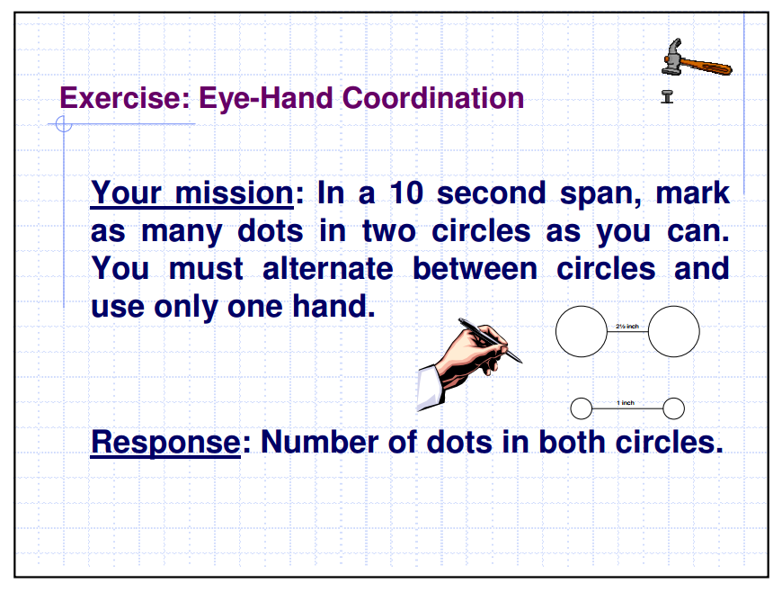

Why are there no standards? How you choose a something between your dominant and non-dominant hand?

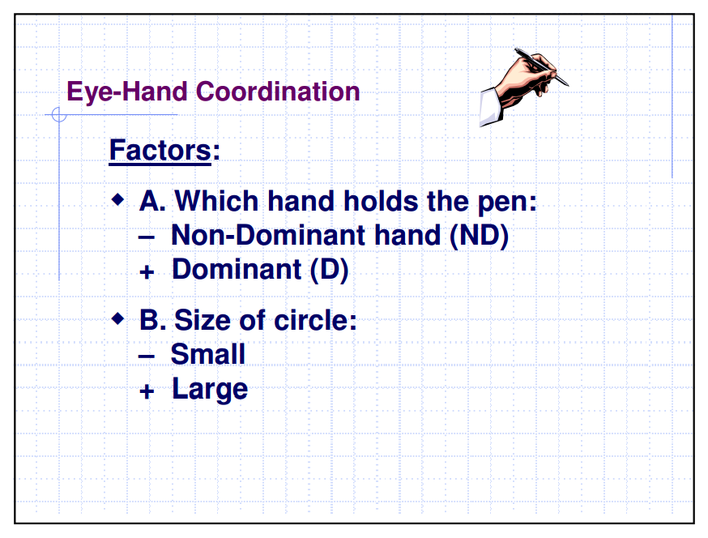

Form a hypothesis here:

Eye-Hand Coordination

Procedure for Doing Exercise

1. Write the numbers 1 through 4 on four slips of paper. Put these in one hand and blindly pull out at random.

Dominant, small: ___

Non-Dominant, small: ___

Dominant, large: ___

Non-Dominant, large: ___

Average Number of Seeds Germinated Data

|  |
| --- |
| Coding of symbols |

|  |  |  |
| --- | --- | --- |
|  |  | Short hand |
| (+) | (+) | + + |
| (-) | (-) | - - |
| (+) | (-) | + - |
| (-) | (+) | - + |

2. Perform tests in random run order. Record data in blank chart provided below.

Use this chart to record your data.

|  |  |  |
| --- | --- | --- |
| Order | Runs | Result |
|  | + + |  |
|  | - - |  |
|  | + - |  |
|  | - + |  |

Why might you want to repeat this experiment more than once?

Perform the test in random order two more times. Record the data below.

|  |  |  |  |  |  |
| --- | --- | --- | --- | --- | --- |
| Order | Runs | Result | Order | Runs | Result |
|  | + + |  |  | + + |  |
|  | - - |  |  | - - |  |
|  | + - |  |  | + - |  |
|  | - + |  |  | - + |  |

Now let’s average these all together. Use the Table below to help you.

|  |  |  |  |  |  |
| --- | --- | --- | --- | --- | --- |
| trials | | First  Run | Second Run | Third  Run | Averages |
|  |  |
| (+) | (+) |  |  |  |  |
| (-) | (-) |  |  |  |  |
| (+) | (-) |  |  |  |  |
| (-) | (+) |  |  |  |  |

Now let’s do the math! **To find each main effect, we will find the high and low averages and subtract them.** First write in the correct averages from the chart above. Now find the average of the two low values. Write it down in the space provided below. Next step, average the high values. Write them in the space provided as well. Now graph your low average at (-1) on the x axis. (You will need to create your own y axis scale for the number of dots.) Next, graph your high average at (+1) on the x axis. Please create a line segment that connects the low point with the high point. **To find the effect value, subtract the low average from the high average. (high average – low average.)**

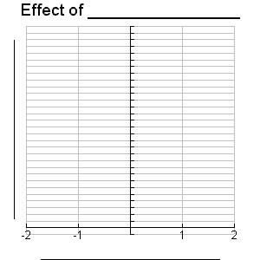

|  |  |
| --- | --- |
| Effect of Hand Dominance | |
| - | + |
|  |  |
|  |  |
|  |  |

Low average High average

Now repeat the process for the second main effect. Don’t forget to draw in your figure. ☺

|  |  |
| --- | --- |
| Effect of Circle Size  [image] | |
|  | + |
|  |  |
|  |  |
|  |  |

Low average High average

Finally, we will calculate the interaction effect. Here we are taking three variables and combining them together. First we must decide which variable we want to be our x axis as we now have two choices, unlike before. So which will it be… hand dominance or circle size? It really is arbitrary and up to you. In fact, you might want to practice both.

So how do you find the interaction effect? Well since you would normally be representing this in three dimensions instead of two, you would be graphing planes. From a side view, planes look like lines, or in our case line segments. **We will calculate the slopes of these line segments and subtract them.**

First, fill in your averages again. Next, label Hand Dominance along the x axis. (The y axis remains unchanged.) Then we will start by creating our high segment for circle size. You need to be careful here. Look at the first ROW and plot the two average points. Then connect them together with a solid segment. This solid segment represents pictorially what happens with our high circle size, as you go from your non dominant hand to your dominant hand. Next look at the second row and plot those average points. Connect them together with a dashed segment. This dashed segment represents pictorially what happens with our low circle size, as you go from your non dominant hand to your dominant hand. Now that you have drawn the segments, find the slope of each of them. Finally subtract the dashed segment slope (small circle size) from the solid segment slope (large circle size). **Put another way the interaction effect value is found by: high segment slope – low segment slope… always.**

Interaction Effect of Hand Dominance and Circle Size

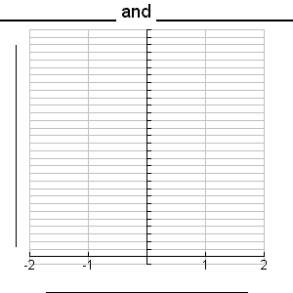

|  |  |  |  |  |
| --- | --- | --- | --- | --- |
|  | | |  | |
| (-) | (+) |
|
|  | Solid Segment | (+) |  |  |
|
| Dotted Segment | (-) |  |  |

Now try it by making Circle Size the x axis. This means that your segments will be about hand dominance.

Interaction Effect of Circle Size and Hand Dominance



|  |  |  |  |  |
| --- | --- | --- | --- | --- |
|  | | |  | |
| (-) | (+) |
|
|  | Solid Segment | (+) |  |  |
|
| Dotted Segment | (-) |  |  |

What do you notice about the two graphs? What about the interaction effect value?

