Ti nSpire: Drawing Circles & Triangles name:_______________
Class: ____ date: ______
- Your first task is to create a circle in the Geometry App. Press [home] and add a Geometry App. This will be the third option of icons on the bottom.
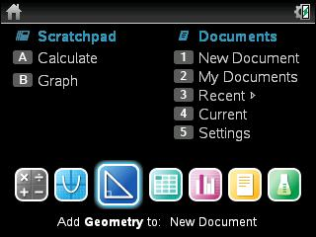
• Construct a circle by pressing [menu] [5] [1].
• Click on a desired location for the center of the circle.
• Move cursor to the desired size of the circle and press [enter].
• Press [esc] to disable the construct circle tool.
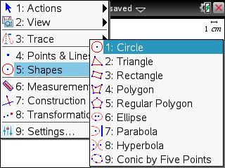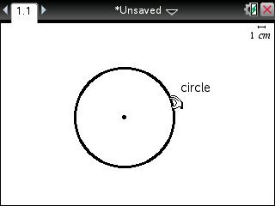
- Your second task will be to find the circumference of the circle.
• Find the circumference of the circle by pressing [menu] [6] [1] and clicking on the circle.
• Move this value away from the circle and press [enter]. Press [esc] to disable the length tool.
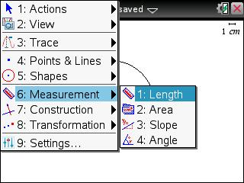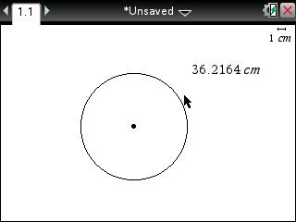
• Move the cursor to the value and press [enter] [ctrl] [var].
• Press [C] [I] [R] [C] [U] [M] [enter].
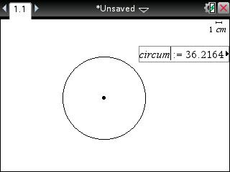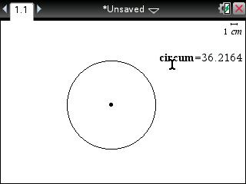
- Your next task will be to capture the circumference data in a list and spreadsheet
• Press [home] [Lists & Spreadsheet].
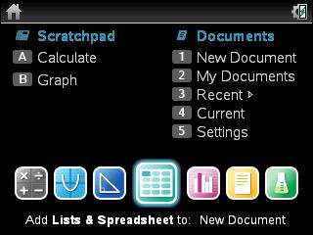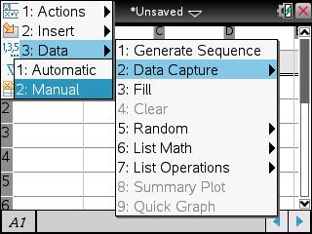
• Press [menu] [3] [2] [2].
• Press [◄] to remove the "var".
• Press [var] [enter] to insert the circum variable.
• Press [enter] again to finish the entry.
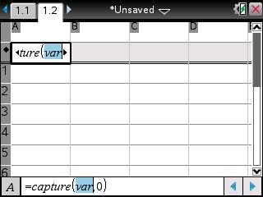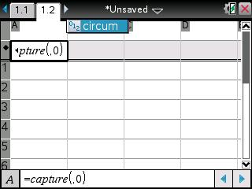
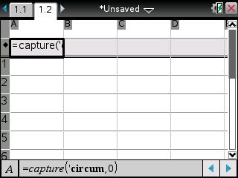

• Navigate back to the Geometry App by pressing [ctrl] [◄].
• Press [ctrl] and click on the circle to grab it.
• Change the circumference of the circle using the arrow keys.
• Press [ctrl] [.] to store the desired circumference value to capture.
• Repeat as necessary.
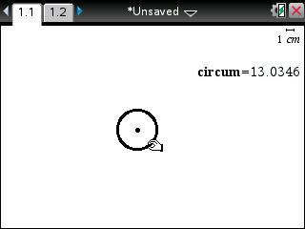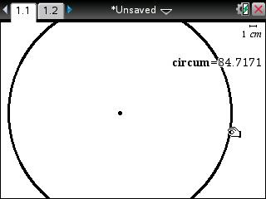
• Return to the Lists & Spreadsheet page, by pressing [ctrl] [►] to view the results. How did you do?
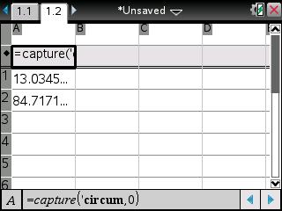

- Go to the Graphing App. Try to graph the following circle equation: (x – 2)² + (y +3)² = 16. Can you do it?
HINT: Is it possible to solve for y?
ANOTHER HINT: You might need to use two equations to graph the entire circle.

- Your next task is to download “Secrets in the Triangle” by Patricia Casey. Then go through ALL fourteen prompts. Be sure that you know how to create your own triangles in the geometry section. In addition, using your nSpire, you MUST know how to construct medians, perpendicular bisectors, angle bisectors, and altitudes without any help.

- Match each point of concurrency with its construction.
A. Median I. Circumcenter
B. Altitude II. Centroid
C. Perpendicular bisector III. Incenter
D. Angle bisector IV. Orthocenter

